Table of Contents
INTRODUCTION
TRICHOLOGY
WHY CYCLICAL NUTRITION?
COMMON TRICHOLOGY CONDITIONS TO KNOW
DANDRUFF
ROLE OF DIET IN HAIR LOSS
FAQS FOR HAIR FACT

Introduction
Hair defines your personality, social image and confidence. Hair loss today is increasing at alarming rates and occurring in the young and old alike. Hair loss can occur with or without any family history and in individuals who are in perfect health, without any abnormalities detected in the lab tests. The presentation of hair loss is changing due to rising pollution, exposure to electromagnetic radiation, UV rays, water quality, pesticides, fertilizers, stress, alcohol, smoking, sleeping patterns, poor eating habits and nutritional deficiencies. All these epigenetic factors dysregulate and deteriorate the cell function influencing genetic expression, making the cells weak and susceptible to action of DHT, androgens, cytokines, prostaglandins, promoting accumulation of free radicals or ROS (Reactive Oxygen Species) mediators of inflammation and other neuro transmitters. The hair can be improved with correction of lifestyle, diet, protection with good hair care and oral supplements to strengthen the roots, restore cellular environment and cell function and promote hair growth. The fact is all this can be achieved without use of anti androgens, enzyme blockers like Finasteride and without any side effects. Good hair growth requires healthy mind and a healthy body. Hair is the mirror of your health.
A holistic approach requires detox, blood purifiers, gut cleansers, immunity boosters, anti anxiety, antioxidants, iron, calcium, zinc, amino acids from easily tolerated natural organic source to achieve good hair growth. We have researched the role of nutrients in hair biology and the inter nutrient interactions to create a low dose efficient Cyclical Nutrition Therapy which delivers wellness, good health and hair growth in men and women at all ages.
The program is patented and used successfully in our own practice in Mumbai for 30 years. It has been used by over 5000 dermatologists, plastic surgeons and trichologists for past 15 years and available as ready to use kits in Australia, USA, Canada, New Zealand, India & UK. Clients using the kits have reported better hair, better skin, better nails, benefits in sleep, wellness and energy levels.
Readership for the controlled clinical trial evaluating the science behind this unique approach and the benefits in hair loss due to androgenetic alopecia, stress, pollution, electromagnetic radiation, trichotillomania, has reached 88,000 reads on prestigious international Researchgate. The studies have been downloaded by over 90 universities in 75 countries around the world and used as citations in 140 different research papers. We are sharing the same knowledge here to empower you and add to the loving care you provide to your clients.
We treat hair without the use of any drugs or medicines, only low dose safe nutrition cycle, which has no side effects. We also avoid topical use of minoxidil which is not well tolerated and instead use a safe, soothing, tripeptide gel for scalp application, which also acts as moisturizer, maintains scalp pH and builds thickness of the hair shafts.
Trichology is a safe branch to practice with no use of medicines. Primary care of all hair conditions can be planned with scalp applications and oral supplements. Over 80-90% of your clients will respond to Hair Fact Cyclical Nutrition kit and Trico gel scalp application. You can combine Hair Growth Laser, LLLT which is US FDA approved for safety. No fear of overdose or side effects and always an option to refer what you cannot decipher to a dermatologist or endocrinologist. You have limited responsibility.

TRICHOLOGY
What is Trichology?
The term Trichology has a Greek origin, where 'tricho' means hair and 'logy' means science. Trichology is the science of hair and scalp disorders. Trichology includes understanding the structure and function of human scalp and hair for providing care to ensure good, healthy, growing hair.
Common hair problems are, loss of hair volume, change of texture, hair beginning to fall flat, having one fixed style to cover the areas of thinning. Patients may present to a trichologist for hair loss, hair shedding, hair breakage, hair thinning, hair texture, dry frizzy hair, scalp disorders, trichodynia, dandruff, seborrheic scalp or need for medical reference.
The expression ‘Hair loss’ could be used by clients to describe various issues. It could mean they are seeing more hair fall than before or they have less hair than before or the scalp is visible through the hair or hair does not look fuller or there are patches or areas of no hair. But it involves a fear of becoming bald.
Clients may present to a trichologist with hair shedding, hair breakage, hair thinning, problems with hair texture or scalp disorders.
Hair shedding: Increase in the number of hairs falling per day. Full length hair being shed off usually with a white end at the roots.
Hair breakage: Brittle hair breaking midway and falling as short or long strands, needs to be differentiated from shedding.
Hair thinning: Is inability to cover the head completely or a see through effect from lack of hair density or thinning from loss of hair diameter or calibre, hair being thin & silky.
Hair texture: Presents as dry, frizzy, wavy, unruly, soft, silky, tangled or difficult to comb.
Scalp disorders: Boils, pustules, seborrheic dermatitis, tinea capitis fungal infection (ringworm), candida yeast infection, bacterial cellulitis, lice and nits, apart from inflammation and scarring alopecias.
Table of contents
- Clinic requirements checklist
- Physician, Trichologist, Cosmetologist recruitment
- Patient information forms
- Reply to patient FAQs
(each section pages are color coded to find easily)
(each section begins with clinic logo on the page)

Clinic requirements checklist

Office
Lease
Signage –
Lobby - Easy to see when approaching the clinic, entrance to the building, floor & lobby. May use more than one if permitted and required.
Door – Signage or name plate or glass door with vinyl decal, logo, suite number & clinic name.

Phones with individual handset that can be carried to any room
Intercom between rooms and reception

High speed internet, may offer free usage to clients,
Office desktop computer with clinic management software
Individual desktops or laptops with optional Lan connected to the reception
Laser printer, Fax, Copier, wireless optional can be used from any room if required

After hours answering service

Printing
Brochures
Business cards
Patient information forms
Patient notes, questions to ask by the consultant,
Treatment plan options with pricelist
Diet advice
Medicine prescription can be printed through the computer
Treatment progress sheet on the computer, (visit, treatment, result)

Website
Credit Card payment, Online payment,
Online product order and purchase,
Customer review Google Link with easy scan QR code

Waiting area
Comfortable seating for 6 – 8 persons, indoor plants, magazines,
Water dispenser, Coffee machine,
Art for the lobby, bright flowers, World map on the wall,
Posters or TV presentation showing series of before and after results displayed
Quotes about good hair

Consulting Room
Medium size, uncluttered table, office chair for the consultant
One chair on the side of the table and two to three chairs for patient and accompanying persons
Cabinet or set of drawers in the table or along the table for storage
Pleasant aroma or scented air spray, optional air purifier
Hair and Skin model on the table
Blood pressure apparatus, (digital on wrist model) – optional
Pulse Oxy meter for finger tip oxygen saturation – optional
Hair cycle Anagen, Catagen, Telogen, model or picture or slide on the computer
List of internal and external causes of hair loss.
Posters of male and female hair loss grades, classification, slide on the computer,
Before / After pictures of various grades of hair loss and various causes of hair loss,
Counseling ppt to explain as you go

Hiring Agency for paramedic staff, Sales staff, Trichologists,
Craigslist.com
PostJobFree.com

Scrubs for working staff,
Lab coats for medic staff,
Smart coat or suite for reception staff,
Clinic Logo, Monogram, Name and Title on the dress pockets

Hair Loss Consultation Form

Name: _____________________________ Date:__________________

Address: ________________________________________

________________________________________

Email: ________________________________________

Date of Birth: _____________________Age: ______________

Occupation: _______________________________________

Telephone: _______________________________________

Family Care Physician: _______________________________________
Stylist/Barber _______________________________________
Address: _______________________________________
_______________________________________
Telephone: ________________________________________

1. When did your hair loss begin? ____________________________________________________
2. Over time how has your hair loss changed? (circle) ◻BETTER ◻WORSE ◻SAME
3. Which part of your head has hair loss?
◻ ALL OVER ◻ FRONT HAIRLINE ◻ CROWN BACK ◻ NAPE ◻ OTHER: ___________________
4. How rapid was the hair loss? ◻ Sudden ◻ Gradual
Shedding is defined as having excessive numbers of hairs falling out daily.
Thinning is defined as having less hair to cover the scalp, with or without excessive hairs lost each day.
5. Do you feel that you have been shedding excessive numbers of hairs (in the shower, on the towel, on your hair brush, pillow, etc.)? ◻YES ◻NO
6. Are your hairs (check one): ◻BREAKING OFF ◻COMING OUT AT THE ROOTS (with a white end)
7. Within 6 months to a year PRIOR to the onset of hair loss: Have you been started on any new medications? ◻YES ◻NO If YES, please list: ________________________________________________________________________________ ________________________________________________________________________________
8. Have you had any hormone pills or birth control pills started or stopped? ◻Yes ◻No
9. Have you been experiencing any significant medical issues in your life, such as the birth of a child, surgery, illness, or hospitalization? ________________________________________________________________________________
9. Have you been experiencing any significant stress, family issues, illness in the family, or work
issues? _________________________________________________________________________
10. Do you have regular sleep 6 hours ◻ YES ◻ NO
11. Are you awake late night between 11pm – 2am ◻ YES ◻ NO
12. Any history of anemia or low iron? ◻ YES ◻ NO
Are you on any treatment for low iron? ◻YES ◻NO If you, please list
_________________________________________________________________________________
_________________________________________________________________________________
13. Any history of thyroid disorders? ◻ YES ◻ NO; Are you on any treatment? ◻ YES ◻ NO
_________________________________________________________________________________
14. Have you had any recent weight loss or change in your diet? _________________________________________________________________________________
15. Are you actively dieting? ◻ YES ◻ NO If so, what type of diet? _________________________________________________________________________________
16. Are you a vegetarian or vegan? ◻ YES ◻ NO
17. Have you had any recent lab work done to diagnose the hair loss? ◻ YES ◻NO **Please include copies of any lab results.
18. Does your scalp itch or sometimes burn or hurt? ◻ YES ◻ NO
19. Do you have pain in the hair roots? ◻ YES ◻ NO
20. Do you have a rash or flaking in your scalp? ◻ YES ◻ NO
21. List any family members with hair loss or thinning hair (any grandparents, parents, or siblings)? _________________________________________________________________________________
22. Please list all the prescription medications, supplements, and shampoos/solutions that you have tried for your hair loss. How long did you use? Did it help? _________________________________________________________________________________ _________________________________________________________________________________ _________________________________________________________________________________
23. Please list the names and dosages of all medications, over-the-counter pills, and hormone pills that you are currently taking and circle the ones that you were taking when your hair began to fall out. _________________________________________________________________________________ _________________________________________________________________________________ _________________________________________________________________________________

24.Please list the names and dosages of all vitamins and natural supplements that you are taking and circle the ones that you were taking when your hair began to fall out: __________________________________________________________________________________ __________________________________________________________________________________ __________________________________________________________________________________
25. How often is your hair colored, chemically processed, or straightened?
◻ Never ◻ Every _____ weeks ◻ Every _____ months

26. For Women: Are your periods: ◻ Regular or ◻Irregular
27. Do you have excessive hair on: ◻ Chin ◻ Face Chest ◻ Abdomen ◻ Legs ◻ None
28. Have you had difficulty becoming pregnant? ◻ YES ◻ NO
29. Are you perimenopausal or postmenopausal? ◻ YES ◻ NO At what age? ____________
30.What do you think is the cause of your hair loss? Anything else you feel is important to share regarding this issue?
_______________________________________________________________________________ _______________________________________________________________________________ _______________________________________________________________________________
31. Do you have ◻ Thalassemia Minor, ◻ Thalassemia Major or ◻ G6PD deficiency?
32. How did you hear about us?
◻ Doctor ◻ Dermatologist ◻Hairstylist ◻Friend ◻ Internet ◻ Other ______________________________________________________________________________
33. Are you interested in hair treatments –
◻ PRP – Platelet Rich Plasma ◻ Hair Growth Laser LLLT ◻ Growth Factor with Karalase Laser
◻ Medical management with nutrients that improve response to DHT, without side effects
◻ Low Level Laser light Therapy – LLLT – FDA approved for safety without side effects
◻ Hair Transplant to replace the lost hair or create a new hair line
34. What is your main concern that you want our attention to?
________________________________________________________________________________
________________________________________________________________________________
34. Currently are you financially able to do something about your hair loss ◻ Yes ◻ No
35. Additional information you would like to share or Question you desire to ask?
__________________________________________________________________________________
_________________________________________________________________________________
____________________________________________________________________________________
____________________________________________________________________________________
Clinical Evaluation Equipment:

Aim and shoot Camera with HD resolution OR SLR Camera
Light Blue or Sky Blue background for taking photographs
Designated area with good ceiling light
Photographs always in the same place, background, light, camera and same setting
Mirror and private area to comb and reset the hair or wear the hair piece

Five Standard camera views
- Front Hairline to Eyebrows with hair pulled back
- Right temporal angle with hair pulled back
- Left temporal angle with hair pulled back
- Top view with head bent forward and center parting
- Whorl or occipital region in males or nape of the neck, or any other area of thinning

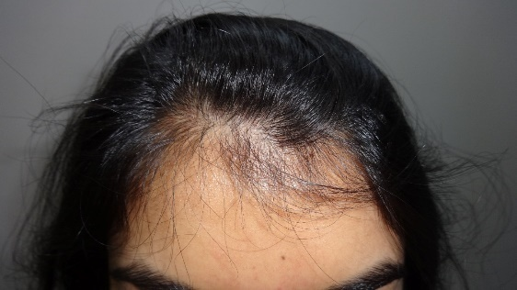 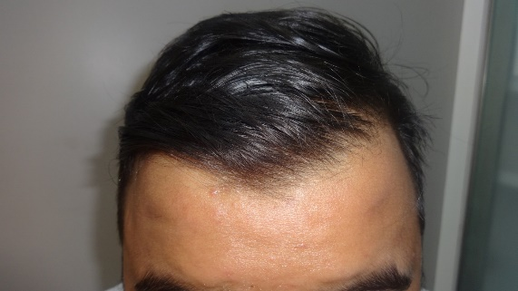 1. Front hair line with hair combed back

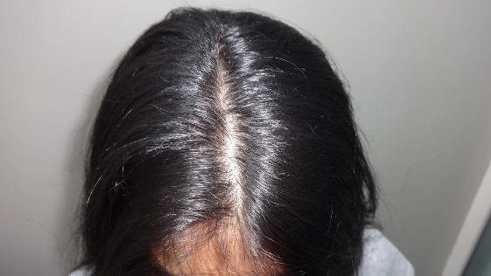 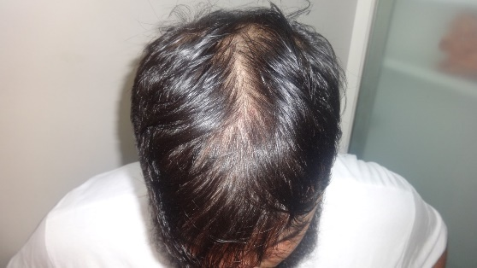 2. Crown or Vertex with center parting

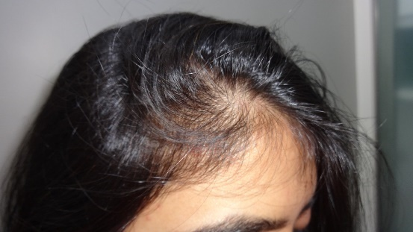 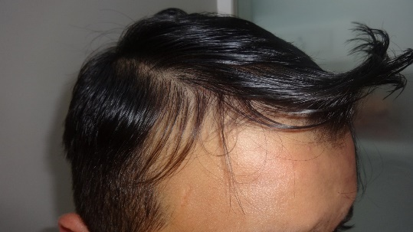 3. Right Temporal angle with hair combed back

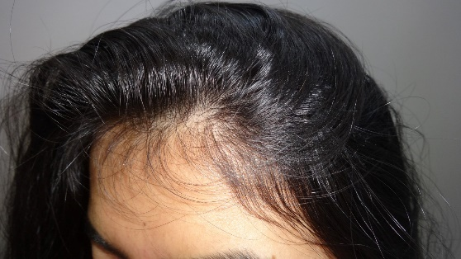 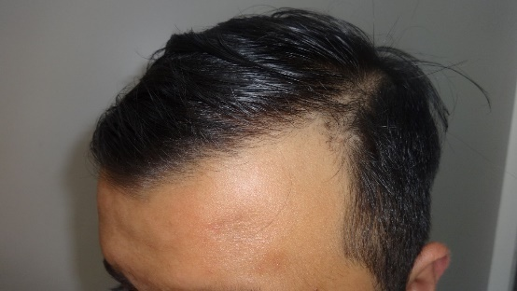 4. Left Temporal angle with hair combed back

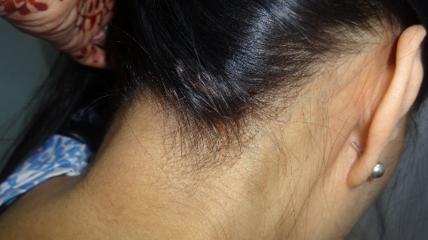 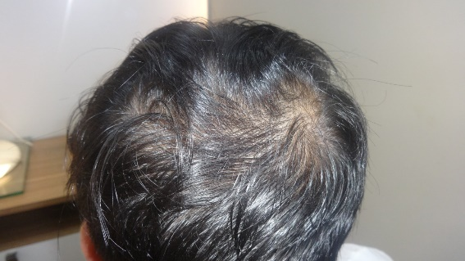 5. Nape of the neck or any other area of concern

Patient Financing options
Pantry, Fridge, Microwave, Wash basin, Clean Toilets
Miscellaneous Office Supplies
Files, Folders, File holding bins, Credit Card Terminals, Thermal Paper, Printer paper,

Clinic name and Logo
Flow for client interaction:
Primary Counselling
Look at clients photos,
Inform and ask the client if you can touch the hair,
Part the hair, lift the hair gently from the corners and the hairline
Use a hand held magnifier with light
Inform that the pattern and the way the hair is thinning indicates Androgenetic Alopecia (AGA) which is progressing towards MPHL or FPHL (Male Pattern Hair Loss or Female Pattern Hair Loss) also referred to as PHL. This may be preceded or associated with hair loss from Telogen Effluvium.
Inquire or refer to the client information sheet for the number of hair shedding or breakage per day.
If this is significant the client may have Telogen Effluvium (TE) which is predisposing as well as commonly associated with AGA or PHL (effluvium in the dictionary means invisible offensive spread or loss),
If there is only shedding and no signs of AGA or PHL, client may be presenting as purely TE.
If the shedding is more than 6 months it is Chronic Telogen Effluvium.
If shedding is persistent beyond 3-4 months it is progressing towards Chronic Telogen Effluvium.
You should tell the client the grade of hair loss and it is most probably AGA progressing to PHL with or without associated TE.
Most common cause for hair loss are hereditary, DHT / androgens, thyroid, inflammation, altered immunity, autoimmunity and nutrition.
Research shows that you can get hair loss without family history and even with normal DHT.
This is because apart from hereditary, there are several causes make the hair follicle sensitive to normal DHT leading to excessive hair loss. These could be – Stress, Sleep, Pollution, water quality, seasonal variation, extreme temperatures, humidity, diet, nutritional deficiencies, smoking, alcohol, preservatives and pesticides in foods, recirculation of air in closed building environments, pollution, electromagnetic radiation, etc.
Though your DHT is not raised these factors make the hair follicles weak and sensitive to normal DHT.
Rule out or confirm the causes:
Hereditary – ruled out by family history on mother’s side as well as father’s side
DHT / Androgens – acne, body hair, oily scalp, excessive sweating, facial hair in women, change of voice, menstrual irregularities, pattern hair loss, high proportion of villus hair,
Hypothyroid tolerate heat better, hyperthyroid tolerate cold better,
Inflammation & Immunity – itching, redness, irritation, pain in the roots, gut issues, poor digestion, frequent illness, stress, patchy hair loss, skin disorders, associated medical conditions,
Nutritional issues – weight watchers, deviation from normal balanced diet, high protein intake, no carb, low fat, keto diet, use of multiple supplements, fat burners, choosy and picky for foods, fast foods, eating too little or too much, high intake of sugar, salt, fried foods,
Lifestyle – smoking, alcohol, recreational choices, keeping awake at night, irregular eating, poor water intake, constipation, achiever attitude, perfectionist, want to correct or check everything
Now examine the hair on the – Trichoscope.
Video Microscope or Trichoscope - hair evaluation
Look for –
- Hair diameter discrepancy (HDD) or Anisotrichosis
- Strong Terminal hair and Villus baby hair. More than one Villus hair for every four Terminal hair, indicates AGA. One in eight indicates Telogen Effluvium (TE).
- Dandruff, Oily Scalp
- Grime, secretions, residue or pollution particles on the scalp
- White build up – hyperkeratosis around the follicle – in scarring alopecias
- Swelling, redness, pigmentation around the follicle
- White / Yellow spots on the scalp
- Blood vessel marking on the scalp
- Tufted Folliculitis, infection around the follicle, scarring on the scalp
- Broken, frayed or cut hair ends, trichotilosis, Trichotillomania
- Small circumscribed hairless patches or scarring
- Hair density and caliber can be visualized, compared but are cannot measured on a video microscope unless you use a Trichoscope with analysis software.
With Video Microscope - Demonstrate to the patient –
- Natural thickness hair and thin, short, weak, slow growing hair.
- Loss of 2 & 3 hair units that are converting to single hair.
- Empty follicles and gaps between the hair.
- Oily scalp, dandruff, hair breakage, blocked ostia or pores, yellow dots, white dots.
- Save the video microscope photos for future comparison every 1-2 months.

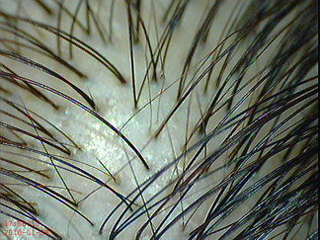 Hair Diameter Discrepancy HDD showing more than four terminal hair for every villus hair suggesting Telogen Effluvium. Four Terminal hair for every villus hair suggests AGA.

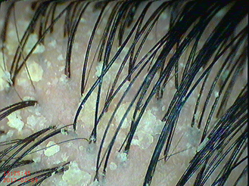 Dandruff

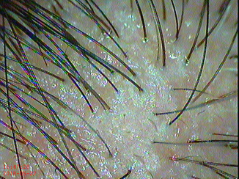 Oily Scalp

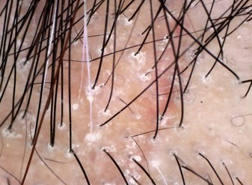 Follicular Hyperkeratosis

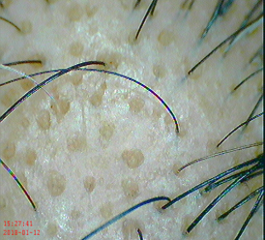 Yellow dots or White dots in AGA & Alopecia Areata

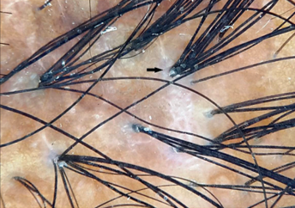 Tufted Folliculitis with scarring of the scalp

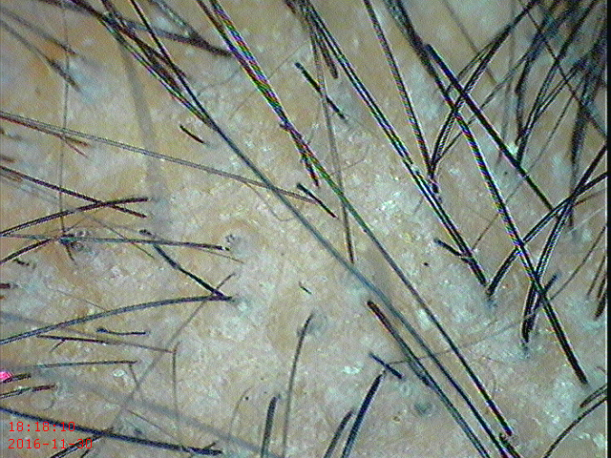 Broken hair ends in Trichotillomania

Demonstrate the variation in terminal (thick) and villus (thin) hair.
Demonstrate normal scalp, oily scalp, dandruff, empty follicles, assure that we can convert these to good growing thick terminal hair with regular hair care program.
The care consists of scalp application or Laser or PRP or Growth Factor treatments to stimulate the hair growth and low dose safe oral supplements to charge the cells, restore cellular function and support active growth.
Proceed to explain each of the treatment options and allow to choose or suggest the best.
Lab tests:
We can ask for the recent blood work or order tests if the clients desire to have tests or if we suspect and desire to look into the tests. You need a doctor to advice and evaluate the lab reports.
Common tests suggested for hair loss:
Investigations and Laboratory tests in a Hair loss patient
CBC, (Complete Blood Count),
Serum Ferritin, Iron Saturation, Iron Binding Capacity,
Serum Protein,
Vitamin B12, Vitamin D3,
Free Tesosterone, DHT levels
Optional Tests and Physician referral:
In Non Menopausal Women – FSH, LH, - H/o (History of) - menstrual irregularities
Blood Sugar – H/o Diabetes in the family
Serum Cortisol – H/o Stress
DHEAS – Hormonal imbalance
Thyroid Function tests – T3, T4, TSH – if suspected
Liver Function Tests – if suspected
Insulin levels, Pelvic Ultrasound – if suspected PCOS – Poly Cystic Overian Syndrome
Advising the Low dose Nutrition Kit and scalp application and hair loss treatments do not require any investigations as these do not use any medications or drugs
Overview of Investigations and Interpretation for various hair loss conditions:

 | Tests for Hair loss conditions
 | Hair disorder | Tests | Diagnosis
 | Female Androgenetic Alopecia FAGA | Prolactin, FSH, LH, DHEAS, Free Testosterone, | Hyperandrogenism
 | Male Androgenetic Alopecia | DHT, Free Testosterone | Hyperandrogenism
 | Telogen Effluvium | Thyroid function, Liver function, Vitamin D3, Vitamin B12, Ferritin, Iron binding capacity or Iron saturation, Blood Sugar, HbA1c, Insulin Resistance, CBC, | Low levels, Endocrine disfunction, Metabolic disorder,
 | Telogen Effluvium | Hair Pull Test raised Anagen:Telogen Ratio between 10-20% or Trichoscopy showing  1 Villus hair for every 4 Terminal hair. Less than 20% Villus hair. White end at the root / bulb of the hair. | Indicates Telogen Effluvium differentiating it from AGA
 | Environment, Sleep disturbance, Poor food selection, Fad diets, Extreme diet, (Keto diet causes biotin deficiency) Stress, Micro Inflammation, Regular Protein & supplement pills | All tests as listed for TE plus Cortisol levels.  Mid shaft hair breakage with or without hair shedding | Hair loss from external factors
 | Alopecia Areata, Alopecia Totalis, Alopecia Universalis | Thyroid function, Liver function, Vitamin D3, Vitamin B12, Ferritin, Iron binding capacity or Iron saturation, Blood Sugar, HbA1c, Insulin Resistance, CBC, ANA & RF. Trichoscopy – yellow spots, Tulip hair, Exclamation mark hair, Hair on the borders plucked easily, white hair regrowth
 | Scarring Alopecias | Trichoscopy - Tufted folliculitis, hyper keratosis, loss of follicular ostia, redness, scarring,
 | Tinea Capitis | KOH (potassium hydroxide), examination under Wood’s lamp or Florescent light.  Short Broken hair. Black spots. | Fungal infection
 | Unclear etiology, mixed signs, failure to respond within 3-4 months | Unexplained overlapping pathology | Scalp Biopsy and Dermatological management
CBC Complete Blood Count, HbA1c Glycosilted Hemoglobin (past 3 months sugar index)
FSH Follicle Stimulating Hormone (Follicles in the Overy – not hair follicles)
LH Luteinizing Hormone, DHEAS Dehydroepiandrosterone sulfate
TSH Thyroid Stimulating Hormone, T3 Triiodothyronine, T4 Tetraiodothyronine,
LFT Liver Function Tests, ANA Antinuclear antibodies, RF Rheumatoid factor,

Common Causes for Telogen Effluvium:
Common Causes of Telogen Effluvium (TE)
Physiological
In newborn babies
Associated with Biological changes
Postpartum, Lactation,
Early AGA & Hereditary Hair loss commences as TE
Injury, Surgery
Fever, Illness
Infection, COVID, Vaccination,
Chronic disease
Hormonal
DHT, Androgens,
Infertility treatment, IVF,
Hormonal imbalance,
Thyroid,
PCOS,
Insulin Resistance, Prolactin,
Nutritional deficiencies
Iron, Calcium, mineral deficiencies
Vitamin D, Vitamin A, Vitamin C, deficiencies
Gut Issues
Gut Dysbiosis, loss of gut microbes
Acidity
Gastro-esophageal-reflux
Irritable Bowel, IBD
Malabsorption
Metabolic
Diabetes, Hypertension
Liver disease, Kidney disease,
Metabolic Syndrome,
Gout (raised Uric acid)
Sleep related
Working in night shifts
Sleep less than 6-8 hours,
Sleep disturbances,
Being awake past midnight,
Altered Circadian Rhythm,
Change in Day - Night rest & activity
Stress
Emotional or Psychological Stress
Physical stress or exhaustion
Competitive Lifestyle
Concern for friends & family
Meeting deadlines
Environmental
Changes in temperature, humidity
Exposure to UV rays
Pollution, Smoke, Smog
Electromagnetic radiation, cell phones
Bright screens, especially after sunset
Seasonal variation
Water Quality
Hard water
Chlorinated Swimming pool water
Desalinated water
Working Conditions
Working around chemical fumes / Heat
Working in pressurized Aircraft Cabins
Working or Flying against day/night time zones
Emergency workers, Health Care, Law officers,
Lifestyle
Smoking, Alcohol, Hookah, Water pipe, Vaping
Food habits
Regular consumption of Colas, Juice
Poor food selection, High sugar, High Salt, High Fat
High dose supplements & protein powders
Fat Burner, Creatinine, Gym Supplements
Restricted eating by Weight watchers
Vegan, Vegetarian, high Meat eaters,
Extreme diets, Fad diets, Fat free diet, Keto Diet
Inadequate water intake, hydration
Chemicals in Food
Preservatives, additives, taste makers
Processed foods
Traces of pesticides, fertilizer, in food,
Endocrine Disrupting Chemicals EDCs in foods
Chicken & Meat injected with hormones, antibiotics
Hormonally enhanced milk produced in dairy farms
Deteriorating Soil, overharvesting & mechanization
40% Loss of mineral content & nutrition in the soil
Rapid growing modified high yield crops, veg, fruits
Exercise
Over exercise, exhaustion, as well as Sedentary life
Hair abuse
Blow dry, Ironing, Straightening,
Frequent Coloring, Perming,
Hair products overuse, wrong selection,
Medications (Detail list additional)
Antibiotics,
Isotretinoin,
Frequent use of Pain killers,
Anti convulsants,
Glaucoma & Gout medicines

10 Step Algorithm for hair loss assessment:
Hair loss
1 Pattern Hair loss MPHL FPHL
10 Frontotemporal FFA, Traction Alopecia
8 Central Scalp CCCA
9 Patchy hair loss Alopecia Areata, Tenia, Trichotillomania
2 Shedding or Telogen Effluvium (TE)
3 Breakage External factors, Environment, Sleep Lifestyle, Hair care, Sleep, Nutrition
4 Hair Pull Test +ve TE, AGA, Alopecia Areata Incognita
5 Trichoscopy 1 in 4 Villus hair - TE 1 in 8 Villus - AGA
6 Trichoscopy Loss of Ostia, Redness, Scarring, Cicatricial Alopecia
7 Oily Scalp, Acne, Seborrheic Dermatitis, Body hair, Menstrual Irregularities - AGA, Lab tests, physician opinion

Hair loss Preliminary assessment by presentation:
 | Presentation | Distribution of Hair loss | Suspected type
 | Pattern | ‘M’ shaped frontal & temporal receding with thinning of the crown, whorl area | MPHL, AGA, from sensitivity to DHT
 |  | Thinning on the Vertex, widening of parting line, Xmas tree like with preservation of the hairline | FPHL from sensitivity to DHT, Hormonal imbalance or nutritional deficiencies
 |  | Frontal thinning with no villus hair, loss of hairline may involve eyebrows | FFA
 |  | Frontal & temporal thinning with villus hair and may retain a fringe of the hairline | Traction alopecia
 |  | All round ring of hair loss involving, frontal, temporal, above the ears, continuing across over nape of the neck | Alopecia Areata, Ophiasis, reverse presentation is Sisaphio, Autoimmune
 | Diffuse | With hair shedding | Telogen Effluvium
 |  | With hair breakage | Environmental, Chemical, external causes or nutritional deficiencies
 |  | Distributed all over the scalp | DUPA, Diffuse unpatterned alopecia, Hormonal, Metabolic or Nutritional
 |  | Easy hair pull out, exclamation mark hair, regrowth of white villus hair | Diffuse Alopecia Areata also called Alopecia Areata Incognita, Autoimmune
 | Patchy | Well circumscribed coin like patch, one or more, easy hair pull out on the borders, exclamation mark hair, regrowth of white villus hair, may involve beard, eyebrow or body hair | Alopecia Areata, Autoimmune
 |  | Lost nearly all hair on the scalp | Alopecia Areata Totalis, Autoimmune
 |  | Lost scalp as well as body hair | Alopecia Areata Universalis, Autoimmune
 |  | Broken stubble like hair ends, good terminal hair all around, commonly temporoparietal area, on side of the dominant hand, occasional hemorrhagic follicles, | Trichotillomania
 |  | Frontotemporal thinning with tight hairstyle, braiding, hair combed back, | Traction Alopecia
 |  | Fragile easily broken, twisted hair, black marks, boggy scalp, | Tinea capitis
 |  | Redness, swelling, tenderness, cellulitis, folliculitis, | Cicatricial Alopecia also known as Scarring Alopecia

Medical History for Drugs causing Hair loss:
Routinely prescribed medicines for common conditions can have hair loss as a side effect. Inquire for details of medical history, past and present medical treatments.

 |  | Drugs causing Hair loss
1 | Oral Contraceptives can cause B6, B12 and Folate, deficiencies
2 | Hormone-replacement therapy (HRT) for women (estrogen or progesterone)
3 | Male androgenic hormones and all forms of testosterone
4 | Anabolic steroids
5 | Steroids for skin conditions or Chronic disease (Prednisone)
6 | Pain Killers or Anti Inflammatory
 |  | Brufen
 |  | Tylenol, Acetaminophen or Paracetamol
 |  | Diclofenac Sodium
7 | Non Steroidal Anti Inflammatory medicines
8 | Acne Medicines
All Vitamin A derivatives or excess consumption of vitamin A can lead to hair loss:
Accutane (isotretinoin)
9 | Antacids, Acidity medications and Ulcer Medications
10 | Thyroid Medicine
11 | Blood Anticoagulants (blood thinners)
 |  | Panwarfin, Sofarin, Coumadin
 |  | Heparin injections
12 | Cholesterol lowering drugs (as well as raised Cholesterol)
 |  | Atronid-S (Clofibrate)
 |  | Lopid (Gemfibrozil)
 |  | All Statin group of Cholesterol lowering drugs
13 | Anticonvulsants
14 | Anti Depressants
15 | Amphetamine – suppressing hunger and keeping awake
16 | Antifungals
17 | Gout drugs
 |  | Allopurinol
18 | Glaucoma
 |  | Timolol Eye drops
19 | Blood pressure Medicines
20 | Heart Medicines
21 | Arthritis Medicines
22 | Parkinson’s disease
23 | Uncontrolled Diabetes
24 | Chemotherapy
25 | Prolonged use or High dose of Vit A, Vit E, Omega 3, Iron, Selenium, Zinc, Amino acids, Protein Powders, Creatinine, Fat burners, Body building supplements, cause hair loss

Indications for Hair Fact Oral Supplements Kit:

 | Hair Fact Oral Supplements Indications | Duration & Results
 | Telogen effluvium | Control of hair fall in 3-4 weeks. New hair growth seen on photographs in 2-3 months.
 | Hair loss without Family History, without raised androgens / DHT or without any cause for Telogen effluvium | Control of hair fall in 3-4 weeks. New hair growth seen on photographs in 2-3 months.
 | Early Androgenetic Alopecia (AGA) | Gradual reversal of miniaturization and new hair growth seen on photographs in 2-3 months.
 | AGA without hyperandrogenism, raised Testosterone or raised DHT | 30-40% new hair growth within 2-3 months.
 | Hair loss due to Stress, Pollution, altered Sleep, Night shifts, | Control of hair fall in 3-4 weeks. New hair growth seen on photographs in 2-3 months.
 | Growing teenagers and Geriatrics with poor eating habits, | Control of hair fall in 3-4 weeks. Improved hair quality in 2-3 months.
 | Hair loss in Keto Diet, High Protein Diet, Fat free diet, etc. | Improved hair growth in 2-3 months.
 | High consumption of Sugar, Colas, Processed foods, | Improvement of deficiencies and reduced craving for sugar.
 | Hair loss with Smoking, Hookah, Vaping, Alcohol, | Improved hair growth in 2-3 months.
 | Thyroid, PCOS, Pigmentation, Hormonal imbalance, | Better hormonal control and improved hair growth in 2-3 months.
 | Perimenopausal, Postmenopausal, Postpartum, Lactating mothers | Improved hair growth in 2-3 months.
 | Iron deficiency, menstrual blood loss, Nutritional deficiencies, | Correction of deficiencies and improved hair growth in 2-3 months.
 | Acne, Oily Scalp, Seborrheic dermatitis, Dandruff, | Control of condition and improved hair growth in 2-3 months.
 | Adjunct in hair loss from Low Immunity, Auto Immune conditions or Inflammation | Control of condition and improved hair growth in 2-3 months.
 | Graying or Premature Canities, | Control of condition and improved hair growth in 2-3 months.
 | Trichodynia, Scalp inflammation, | Control of condition and improved hair growth in 2-3 months.
 | Gut Dysbiosis, loss of gut microbes, Acidity, | Control of condition and improved hair growth in 2-3 months.
 | Gastro-esophageal-reflux GERD, Irritable Bowel IBD, Post Bariatric Surgery, | Improved hair growth in 2-3 months.
 | Diabetes, Hypertension, Liver disease, Metabolic disorders | Better control of condition and improved hair growth in 2-3 months.
 | Exposure to Chemicals, UV rays, Electromagnetic Radiation | Improved hair growth in 2-3 months.
 | Damage from Hard water, Chlorine in Swimming pools, | Improved hair growth in 2-3 months.
 | Damage from Blow drying, Straightening, Relaxers, | Improved hair growth in 2-3 months.
 | Early Traction Alopecia, CCCA, FFA, adjunct in Scarring Alopecias | Control of condition and improved hair growth in 2-3 months.
 | Early MPHL, FPHL, DUPA, | Control of condition and improved hair growth in 2-3 months.
 | Post COVID Hair loss, | Improved hair growth in 2-3 months.
 | Short Anagen Syndrome, Lose Anagen Syndrome | Improved hair growth in 2-3 months.
 | Ealy Monilethrix, Trichotillomania, Trichorrhexis Nodosa, | Improved hair growth in 2-3 months.
 | Hair Regrowth requires stimulation as well as support for rapid growing cells. For best results, always add Tricho Gel scalp application. A quarter coin size gel applied once or twice a day.

Contraindications for Hair Fact Oral Supplements:

Contraindications for Follicular Advanced Cyclical Therapy
Iron contraindicated in Thalassemia, Haemochromatosis, Sickle cell anemia,
Pro Immune kits do not have Iron, have Lactoferrin – improves iron metabolism
Calcium contraindicated in renal stones
Protein contraindicated in raised Uric acid levels, Kidney disease, Liver disorders, Gout
Excess Vit C avoided in G6PD deficiency cases
Iodine contraindicated in certain Thyroid disorders as per physician advice
During Cancer Chemotherapy use of antioxidants and vitamins can provide protection to the cancer cells. Start after completion of Chemotherapy, only as per physician advice
Vitamin A containing kits may be restricted in patients on Isotretinoin for acne
Vitamin B12 / Vitamin D3, may be restricted in patients with high B12 / D3 levels

Role of Diet in Hair loss
Masumi Inaba of Japan has shown a cause and effect relationship between the diet and the severity of hair loss through documentation and scalp biopsies. The conversion of testosterone to DHT takes place in the oil and sebum glands of the scalp. We advice our patients to avoid fried foods, bakery foods and red meat in order to reduce the over activity of oil and sebum glands. Hyperactive of these glands may lead to more formation of DHT. Restricting these foods, also reduces the accumulation of free radicals which are not favorable for rapidly multiplying hair follicle cells.
Next is to avoid sugar based foods, as chocolates, pastries, sweets, (some sugar in tea or coffee is permitted). Increased sugar leads to insulin release, which in turn causes release of testosterone from its binding protein and makes it available for conversion to DHT.
Foods with artificial flavors, taste makers, additives, preservatives, colas are avoided as these chemicals lead to formation of free radicals in the body. Juices are best avoided for their fruit sugar, better is to eat fruits (like apple) along with the fruit skin. Nutrients and vitamins in the fruit are concentrated just below the fruit skin, the fruit pulp contains only fructose sugar and water. Having fruits with the fruit skin provides fiber as well as micro nutrients.
Fast foods are avoided for lack of nutrition, use of chemical flavouring agents, additives and preservatives. Chinese foods if prepared with aginomoto MSG (magic salt), can adversely affect hair.
Animals reared for meat are fed antibiotics to prevent them from falling sick. Hormones are used to promote faster weight gain in the farm animals. All these hormones and drug residues affect our body systems when we consume the meat. All animal sources are acidic. Including a variety of vegetarian sources like steamed sprouts, green vegetables, salads, all kinds of beans, pulses, mushrooms, cottage cheese, chick peas and nuts can improve hair growth and providing vegetarian protein, antioxidants and reducing the ill effects of meat.
Vitamins are of two kinds water soluble and fat soluble Vit A, D, E, K. Adding a spoon of ghee (clarified butter), olive oil or cheese can provide the fat soluble vitamins required for the shine, bounce and luster in the hair. Strict no fat diet makes the hair dry, lifeless and falling flat. Also having 12 glasses of water in a day maintains skin hydration and prevents dryness.
One of the theories for hair loss is the reduced blood flow or ischemia theory. Avoid smoking if you are loosing hair. Smoking, vaping, hookah, will constrict blood flow to the hair roots causing ischemia which leads to hair loss. These also cause accumulation of free radicals which are harmful to the growing hair roots.
Diet Modification to improve hair growth
Hair cycle consist of anagen, catagen and telogen. After telogen the hair follicle has to come back into anagen, for which sudden rapid cell division is required at a high metabolic rate. If body environment is not suitable for this rapid cell division, the hair roots remain in a dormant or resting phase. Telogen is a phase to conserve the hair follicle and regrow them later under favorable conditions. When conditions do not improve the hair suffers chronic telogen, remaining in a continuous dormant or resting phase.
Diet and nutrition play an important role in hair growth. The metabolic turnover of hair follicle cells is second only to bone marrow and intestinal epithelium. Rapid cell division and growth requires a toxin free environment and supply of good nutrients to support the rapidly dividing cells. Food consumption today is irregular, at odd hours, against body rhythm or cycle. Food consumed is against local climatic, regional or seasonal preferences. The nutritive value of food has reduced. The nutritive value of soil itself has reduced.
The food consumed today is no more natural it is man made and modified. Yield is increased by using artificial chemicals, hormones, insecticides, fertilizers. Chicken are force fed keeping lights on at night to make them feel it is day time. Residues of antibiotics, anti helminthics, vaccines and hormones injected to ensure disease free rapid growth, are consumed by us with the meat. High protein diets favored by fitness experts are also called the acid ash diet. These create acid during their metabolism, cause the blood to become acidic leading to reabsorption of calcium into blood to counter the acidity. There is increase in the urea nitrogenous waste from high protein consumption, accumulation of these metabolic toxins makes internal body environment unsuitable for rapid cell division and hair growth.
You could count many friends who do not follow any diet or Lifestyle modification but have nice growing hair. Please remember, that they are born with a different type of hair. If you are losing hair you must follow these guidelines. We do not ask you to stop your favorite foods but to restrict them in frequency and quantity. Do not restrict to one kind of food choice, use all kinds of foods in rotation without consuming repeated excess of any. Give all foods a chance to provide you with a variety of nutrients.

DIET ADVICE (INDIAN)

List of Foods to Avoid
- Mutton, Red meat, Fish Fry, Chicken. Two pieces cooked without frying avoid the gravy.
- Two eggs not more than two to three times a week.
- Coconut gravy, groundnuts or peanuts, excess potato, pasta & noodles.
- Fried foods – wada, samosa, puri, papad, dosas, chips etc.
- Sugar foods – chocolates, pastries, cakes, ice cream, sweets, desserts etc.
- Bakery foods – biscuits, toasts, khari, puffs, patties, rolls, croissants, doughnuts, cup cakes etc.
- Chinese foods – agino moto or Chinese salt is bad for hair.
- Fast foods – Pizzas, Burgers, Canned foods.
- Colas, Coke, Pepsi, soft drinks & all kinds of Juice.
- Strictly NO SMOKING

List of Foods to Add in your Diet
- Steamed Sprouts – 2 times a week,
- Green leafy vegetables – 2 times a week,
- Green Beans – 2 times a week, like Gavar, Chawli, Wal, Papdi, French Beans, broad beans, Ghewda.
- Raw Salads – Radish, Beet root, Carrot, Cucumber, Tomato, etc. cut and add salt, pepper, a dash of lime, no mayonnaise, no salad dressing, no sauce.
- Dry beans like Rajma, black beans, yellow beans, kidney beans – twice a week.
- All types of dals – black dal, yellow dal – turn by turn – daily.
- Mushrooms, Paneer (Cottage Cheese), Chola (Chick peas), Soya, Tofu – each - once a week.
- 4 – Walnuts / 4 – Almonds on alternate days.
- 1 – glass milk per day or a bowl of Curd or Yogurt.
- 1– tsf ghee per day or 1 – slice of cheese per day.
- 4 Fresh Fruits per day – cut & eat, with the fruit skin – fresh juice within 20 minutes.
- 10 – 12 glasses of Water per day, especially while flying and during night shifts.

DIET ADVICE (WESTERN)

List of Foods to Avoid:
- Fried Chicken, prefer grilled chicken twice a week.
- Avoid Beef, Pork, Lamb, Fish, Sea food, any one of them can be had not more than twice a week.
- Avoid Potato, Pasta, Cream and melted cheese not more than twice a week.
- Avoid Sugar foods – Chocolates, Pastries, Cakes, Ice cream, Desserts etc.
- Best to stop, Chips, Fries, Tortillas, Nachos, Doritos, Processed foods.
- Best to stop, Coke, Pepsi, soft drinks, pre packed juices, you may have fresh juice.
- Avoid Bakery foods – Biscuits, Puffs, Rolls, Croissants, Doughnuts, White Bread.
- Chinese foods – agino moto or Chinese salt is bad for hair.
- Fast foods – Pizzas, Burgers, Canned foods
- Restrict Alcohol to two Beers or two Hard drinks 2 - 3 times a week.
- Coffee and tea are restricted to 2 -3 cups a day.
- Strictly NO SMOKING, Vaping, Hookah, keep away from passive smoke as well.

List of Foods to Add in your Diet:
- Steamed Sprouts 2 times a week,
- Green leafy vegetables 2 times a week,
- Lima Beans, Fava Beans, French Beans, Broad beans, Colored Beans, Black Beans, Kidney Beans - rotate the choice to have them 2 - 3 times a week.
- Salads with one meal everyday – Beet root, Carrot, Cucumber, Tomato, Greens, add salt, pepper, a dash of lime, no mayonnaise, no salad dressing, no sauces.
- Cottage Cheese, Chick peas, Tofu, Mushroom, Lentils - rotate the choice 2 - 3 times a week.
- 10-12 Non Salted Walnuts, Almonds, Nuts everyday by rotation. Avoid excess of Peanuts, Cashew nuts and Macadamia nuts.
- Low fat dairy products, slice of cheese, olive oil dressing – include in the diet, 3 times a week.
- One glass of milk or a bowl of probiotic curd or probiotic yogurt every alternate day.
- Two Fresh Fruits per day – cut & eat, with the fruit skin (like apple, pear). Freshly squeezed juice can be consumed within 10-15 minutes of preparation.
- Have 2 - 3 cups of green tea or hot water every day.
- Have 10-12 glasses of water every day.
- Have a Balanced diet Avoid High Protein Intake, Excess Whey Protein, Keto diet, Fat Free diet, Crash dieting & extreme diets.

Additional Information
Medicines to be avoided in G6PD deficiency:
 | Medicine group type | Individual drugs
 | Antimalerials | Primaquine, Pamaquine, Chloroquine
 | Sulphonamides & Sulphones | Albucid, Sulphacetamida, Sulphadimidine, Sulphapyridine, Sulphanilamide,
 | Sulphafurazole | Gantrisin, Salicylazosulphapyridine, Salazopyrin, Dapsone, Sulphoxone, Glucosulphone Sodium, Promin, Cotrimoxazole,
 | Antihelminthics | B-Napthol, Biblophan, Niridazoole,
 | Antibacterials | Nitrofurans, Nitrofurantoin, Furzolidone, Nitrofurazone, Nalidixic acid, Chloramphenicol, P-Aminosalycylic acid
 | Analgesics | Analgesics Permitted are – Acetylsalicylic acid (Aspirin), low dose can be used, Acetophenitidin (Phenacetin) Paracetamol is safe
 | Miscellaneous | Fava beans, VIt K analogues, 1mg menaphone can be given to babies, Napthalene, Probenacid, Dimercaprol (BAL), Mythylene blue, Arsin, Phenythydrazine, Acetylphenylhydrazine, Toludine blue, Mepacrine, Qunolone group of drugs.

Understanding Dandruff
What is dandruff?
A few million body cell from outer layer of the skin shed every day. These dead cells stick to form clumps presenting as dandruff. Oily secretion of sebum from the scalp, is broken down to fatty acids and triglyceride, oleic acid by Malassezi yeast also known as Pitryosporum ovale and failure to wash off this accumulation, binds along the dead cells to form flakes or oily dandruff. Oleic acid causes easy separation and shedding of the stratum corneum skin layer cells further increasing the exfoliation. Dandruff can also occur from excessive shedding and dead cells reacting with sweat, without rise in oily secretions, which appears as dry white powder, recognized as dry dandruff.
Dandruff propagates a vicious cycle. Once there is dandruff, it causes itching, leading to nail scratching and injury to the outer protective layer of the skin, this breaks the protective layer allowing easy penetration to more organisms and inflammation leading to more irritation and more dandruff. Dandruff can occur over other oily or hairy areas like chest, eyebrows, nose, beard & ears.
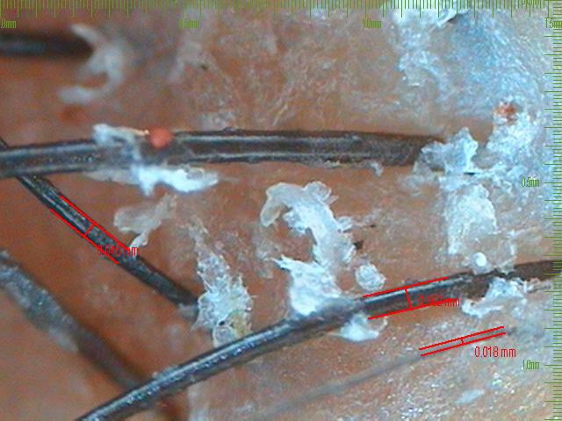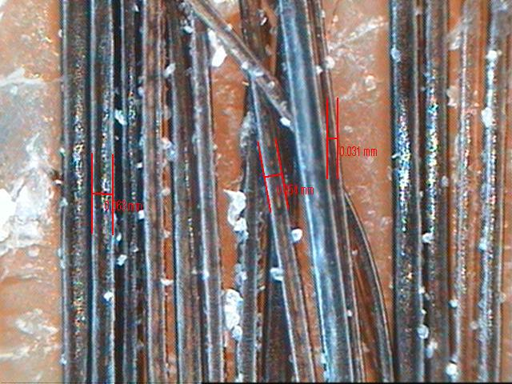

Dandruff is caused & triggered by – oily scalp, excessive sweating, infrequent washing, poor scalp hygiene, yeast and fungal infections, irritation of the scalp to pollution, chemicals, fumes, soaps, shampoos, hair products, gels, sprays, alcohol containing lotions, applied medications, sweating, high humidity, extreme weathers, exposure to sunlight, excess heat or cold, air conditioner blowing on the scalp, continuous AC environment has effect of VOCs volatile organic compounds in the AC atmosphere. People staying or working around construction areas with dust, dirt, cement blowing in the air, frequent commuting with suspended particles and wind blowing in the hair lead to dandruff. Frequent washing and pre oiling or using leave on serum can protect the hair. Emotional and mental stress, fatigue, affect oil and sweat glands creating dandruff. Dandruff may not be hereditary, but the habits and lifestyle followed in the same family may affect entire family in the same way causing dandruff. Dandruff as such is not contagious but the fungal and yeast infection may be transmitted by contact and sharing unclean combs or towels. Neurological diseases, stroke, low immunity diseases, chronic illness and obese patients have dandruff.
Treatment
Dandruff is like sweating, it is a apart of the body function to shed off cells. We cannot make dandruff zero, it can be controlled or reduced. We can prevent associated fungal infection and irritation. Best way to keep dandruff away is to wash regularly. Regular use or daily use shampoo is good. You do not need anti dandruff or anti fungal shampoos unless you have infection. If you find redness, unstoppable itching, irritation, burning, pain in the hair roots, thick flakes of dandruff not responding to regular shampoos, it is time to consult your doctor.
The correct way to use scalp cleansers and anti dandruff shampoos is to wet the hair, massage the shampoo into the roots, leave it for 3-5 minutes and then wash. This allows time for action of the treating agent. For inflamed scalp earlier use of cortisone creams, lotions is now replaced by better option of non-axis locally acting agents like 0.01% Fluocinolone lotions & prescription shampoos. Effective remedies 2% Ketconazole is antifungal (keep away from 1% is not effective). For resistant fungal infection Ciclopirox is newer alternative. Cotrimazole and Piroctone olamine are other anti fungals. Coal tar can reduce excessive shedding of cells. Zinc pyrithione called ZPT / ZPTO regulates sebum production, keratinization and reduces the yeast as well. Selenium sulfide is effective in reducing sebum. Milk of magnesia local application is an old effective remedy.
Natural remedies – twice a week for 30-60 minutes
Aloe vera, Tea tree oil, Coconut oil, Olive oil, Avocado extract, Fresh curd or lime juice for flaky dandruff.
One part white vinegar with 4 parts of water also helps to cleanse the scalp and prevent dandruff.
Phototherapy
Natural and artificial UVA, UVB radiation, red and blue LED Light curbs growth of Mallassezia yeast, reduces sebum and inflammation. Modern treatment is Low Light Laser Therapy for 20 minutes once or twice a week.
Diet for dandruff control
Avoid fried foods, sugar based foods, artificial flavors, additives, preservatives, regular meat, agino moto in Chinese preparations. This reduces activity of the oil and sweat glands, reduces post meal rise in androgens and promotes healthy scalp.
Add enough water 8-10 glasses to hydrate the scalp, 2 fresh fruits, greens, salads, turn by turn sprouts, chick peas, mushrooms, cottage cheese, tofu, all kinds of dals, beans and one green leafy vegetable a week.
Nutritional Supplements
Probiotics, Vitamin, B2, B3, B6, B7 (Biotin), Zinc, antioxidants to fight formation of free radicals and peroxides in the scalp. Adequate sleep, good breathing exercise which improves blood flow to the scalp can help in having better scalp health.
Short hair cut – reduces build up of humidity, inhibits yeast, allows air and sun light, makes easy to wash care and manage the hair till you tide over the problem.

Why does one get redness itching and scabs or crusts?
Fungal infection causes itching. Repeated scratching and irritation with the nails causes redness and injury. Injury invites bacterial infection, which causes hairloss. The injury heals with scabs and fibrosis, which again causes hairloss. Dry, dead, exfoliated skin trapped in the hair causes the crusts or shiny flakes that fall off when you scratch or comb or handle, the hair. This could be due to improper cleaning or excess formation of dandruff.

How can dandruff cause hairloss?
Dandruff is extremely annoying. It causes social embarrassment and can lead to scalp infection and hair fall. Fungal infection and /or low grade bacterial infection then, warrant antibiotics, capsules and scalp lotions. Infected glands and hair roots heal with fibrosis, which strangulates the blood supply and results in hair fall. In severe cases or with repetition of this cycle the hair loss becomes permanent.

These are the categories and levels of affiliation suggested

 | Silver Affiliate | Gold Affiliate | Platinum Affiliate
1 | Website Link with Zip code &  ‘Find your closest Trichologist’ | Website Link with Zip code &  ‘Find your closest Trichologist’ | Website Link with Zip code &  ‘Find your closest Trichologist’
2 | Products at Regular Discount | Products at Regular Discount | Products at Better Discount
3 | Consultation at $75 per client | Consultation at $75 per client | Consultation at $75 per client
4 | 1 day of training product knowledge and a recap of using the Video Microscope FireFly or Dinolite | Trichology Information Book  2 day training included product knowledge and understanding of trichoscopy. | Trichology Information Book plus Educational Classes In clinic hand on training , product knowledge and trichoscopy
 | Fees $1500 | Fees $2500 | Fees $3500
 | For Trichoscopy we recommend FireFly DE350 Dermatoscope from Amazon | For Trichoscopy we recommend FireFly DE350 Dermatoscope from Amazon | Trichoscopy with in depth analysis , providing a sophisticated trichoscopy report with key fundamentals for a professional hair consultation

Products
Hair FACT – Follicular Advance Cyclical Therapy
Tricho Gel – Tripeptide Gel with Copper peptide Keravis and Biotinyl GHK
 | Oral Supplements Kit | Composition | Wholesale | Retail
1 | Hair Fact Women’s - 4 months Kit, Six formulation bottles of 32 tablets / capsules in each | Antioxidants, Iron, Calcium, Omega 3, Biotin, Amino acids, each administered on different days in synergistic combinations, as once in 3 days cycle | $99.00 plus Shipping | $189.00 - $210.00
2 | Hair Fact Men’s - 4 months Kit, Six formulation bottles of 32 tablets / capsules in each |  | $99.00 plus Shipping | $189.00 - $210.00
3 | Pro Immune Women’s - 4 months Kit, Six formulation bottles of 32 tablets / capsules in each | Antioxidants, Iron, Calcium, Omega 3, Biotin, Amino acids, plus Lactoferrin, Colostrum & additional ingredients, each administered on different days in synergistic combinations, as once in 3 days cycle | $119.00 plus Shipping | $240.00 & above
4 | Pro Immune Men’s - 4 months Kit, Six formulation bottles of 32 tablets / capsules in each |  | $119.00 plus Shipping | $240.00 & above
5 | Tricho Gel 120 gram tube | Tripeptide Gel with Copper peptide and Biotinyl GHK  Prevents, dryness, itching, acts as moisturizer & scalp conditioning agent | $18 plus Shipping | $35
 | Bulk orders at 20% discount plus Shipping

HAIR LOSS - Interaction with the clients
First question a client asks is What is the cause for my hair loss? What is wrong with me? Why me?
You are not sick. There is nothing wrong with you. The hair loss is due to excess damage being suffered by the hair from the surroundings, pollution, exposure to UV rays, electronic screens, water quality, pesticides, chemicals in foods, seasonal variations, humidity, continuous air conditioning, living in closed buildings, stress, alcohol, smoking, sleeping patterns, lifestyle, nutritional deficiencies, lack of exercise. High protein intake, fat free diet, no carb diet, crash dieting, rapid weight loss, restricted eating to avoid weight gain, use of fat burners, steroids, multiple supplements, medicines causing hair loss, poor hair care, exposure to heat, cold, chemicals, swimming, blow drying, ironing, colouring, recovery from emotional episode, illness, fever, surgery or physical exertion, everything causes hair loss.
Fight the cause or strengthen the hair?
There are many people around you who are exposed to the same water, pollution, lifestyle but are growing good hair. You are losing hair because your hair is weak and is getting hit by trivial, unsuspected causes. The answer is not in fighting the cause but strengthening the hair. If you treat one cause hair will fall for another cause. But once the hair is strong it can stand against any cause. Fighting the causes requires medications, anti hormones, enzyme blockers with suspected side effects. Strengthening the roots can be done with safe low dose vitamin, minerals and nutritional supplements which work to your advantage.
Loss of self esteem
Hair loss clients are worried, distressed, emotionally upset, having loss of confidence and loss of self esteem. You need to listen patiently, offer reassurance and start treatment without wasting time on too many tests and biopsies. They need explanation of the treatment with a timeline for expecting positive results. The results can be seen along the hairline, along the parting line, along the margins of the temporal corners, with serial photographs taken every two months. You can also record the density per square cm and the hair calibre if you use a trichoscope with hair analysis software.
Self help
Patient start reading from the net and get misleading information. Most trichologists and doctors believe that male hormone testosterone gets converted to DHT which causes hair loss. The theory was proposed in early 1940 more as social observation than with direct scientific study of the hair growth cycles. Alopecia means hair loss. Since it was suspected that the hair loss occurs due to hereditary or genetic predisposition and due to effect of androgens or DHT the name was coined to call it androgenetic alopecia. Today it is proven that such hair loss can occur without raise in androgen levels and even without any family history. Now the name of this hair loss is changed to male pattern baldness and female pattern baldness termed as MPHL and FPHL. If the hair loss does not follow any pattern it is categorised as diffuse unpatterned alopecia or DUPA.
It is observed that DHT levels in most hair loss patients are normal. Researchers today agree that not raised DHT levels but altered end organ sensitivity of the hair follicles to DHT leads to miniaturization and baldness. This sensitivity may be from genetic predisposition or acquired by effect of factors that alter cellular response through disruption of cellular activities and dysregulation of hair growth cycles.
Cellular activity can be affected by inflammation, immunity, accumulation of ROS reactive oxygen species, RNS reactive nitrogen species, peroxides or free radicals, also commonly referred to as toxins. The changes make cells weak, sensitive and vulnerable. DHT acts as an opportunistic intruder and attacks inflicting damage only to these weak cells. All these causes that weaken the cells, can be improved with a correct combination of antioxidants, vitamins and nutrients used to strengthen the cells.
We can reverse the damage and also grow new hair within 2-4 months with a well planned program that restores cell function using nutritional support and then maintain the new growth with a lower dose after getting good results over the first 6-8 months.
Hair Structure:

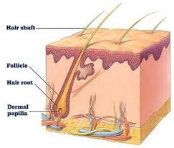

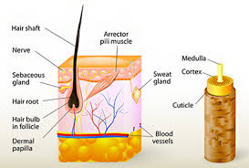

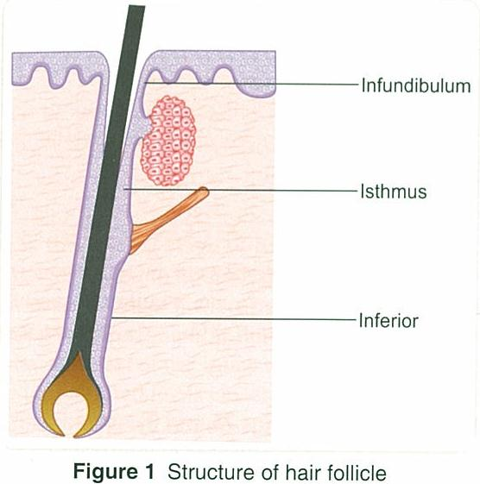

Rounded lower end of the hair follicle is called the hair bulb or hair root. The hair follicle has three parts. The lower segment from the base of the follicle to the insertion of the arrector pili muscle, consists of the bulb and the suprabulb area. The middle segment called the isthmus, is a short section from the insertion of the arrector pili muscle to the entrance of the sebaceous gland duct. The upper segment called the infundibulum, extends from the entrance of the sebaceous gland duct to the follicular orifice or ostia.
The hair bulb contains the dermal papilla which has minute microscopic blood capillaries. Dermal papilla (DP) is the source of growing hair cells that gradually become dead as they are filled with keratin and are pushed upwards to form the hair shaft. The dermal papilla is embedded into the surrounded extra cellular matrix (ECM) consisting of collagen, fibroblasts, cells, proteins and regulating factors. DHT acts only on the dermal papilla. Several other factors acting on the ECM, root sheaths, anchoring the hair follicle, hair shaft, stem cells etc. can cause hair loss.
Layers of the hair:
- The hair shaft has three layers: the cuticle (outer layer), cortex (middle layer) and medulla (inner layer). The medulla is discontinuous in thin hair and is absent in villus or baby hair.
- The cortex gives flexibility and tensile (stretching) strength to hair. The cortex is made of keratin fibres and the cortex cells are filled with keratin. Two types of melanin granules, eumelanin (black and brown)and pheomelanin (red and orange) in the cortex, give different colours to the hair.
- The cuticle is made of layers of overlapping keratin scales arranged like shingles or tiles on the roof. Thick, course hair have more overlapping layers of cuticle than thin fine hair.

BASIC HAIR STRUCTURE
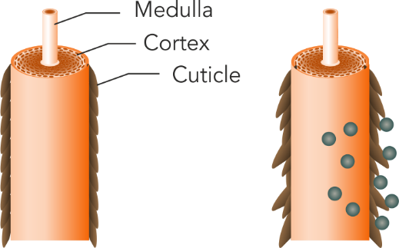
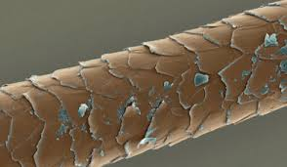
Dust and Grime on the Hair

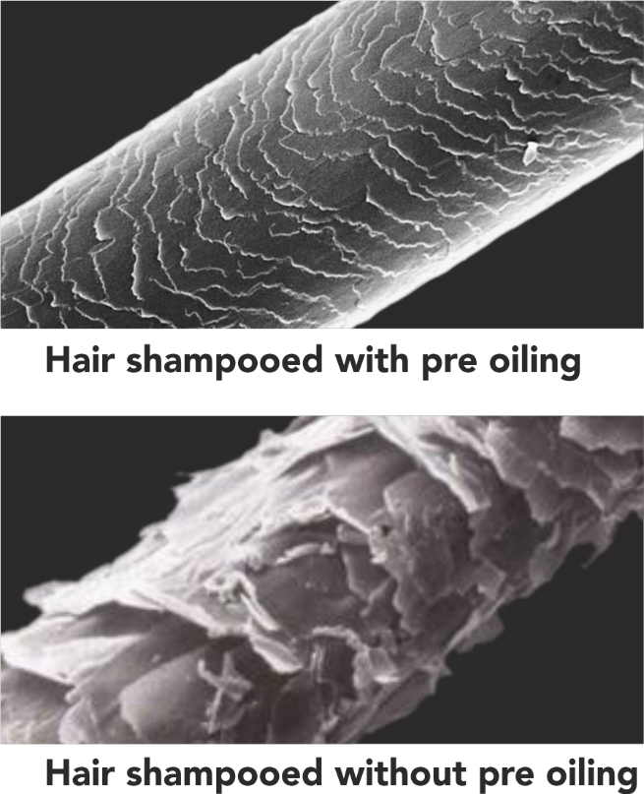
Three types of Hair:
Straight to wavy hair - commonly in Asian hair. Round cross section hair, low density, fast growth, black to dark brown. Prone to thinning, loss of moisture, has good porosity, responds well to hair care and treatments.
Wavy to Curly hair - common in western, Caucasian hair. Oval cross section hair, high density, medium growth, golden blond, brunette or red. Prone to thinning, average porosity, requires careful selection of products.
Curly to coiled or kinky hair - common in Afro American hair. Oval to elliptical cross section, flatter hair, low density, slow growth, black hair. Low porosity, difficult to treat, requires special products, oils and moisturizers. Prone to dryness, breakage, traction alopecia and CCCA Central Centrifugal Cicatricial Alopecia. Coiled hair appears longer when pulled straight.
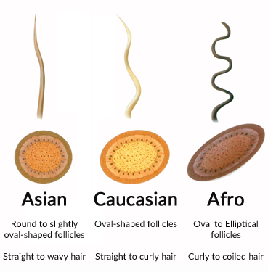
 | Asian | Caucasian | Afro
Cross Section | Round ostium | Oval ostium | Elliptical ostium
Rate of Growth | 1.3 cm per month | 1.2 cm per month | 0.9 cm per month
Density | 170 per sq cm | 200 per sq cm | 160 per sq cm
Average Hair/Unit | 1.5 hair per unit | 2 hair per unit | 3 hair per unit
Total number of hair on the scalp | 90-120,000 total hair | 85-150,000 total hair, Blond 146,000, Brunette 100,000, Red head 85,000 | 50-100,000 total hair
Common Problems | Prone to thinning, longhair loses moisture, good porosity, responds well | Prone to thinning, average porosity, careful selection of products | Traction, CCCA, dry, breakage, low porosity, requires special products, oils & moisturizers
Care | Easier to maintain |  | American Afro High Sulphur content making it sensitive to routine treatments

Hair Cycle:
Anagen 3-4 years, Catagen 3-4 weeks, Telogen 3-4 months - New empty Follicle stage - Kenogen
Hair follicle cycle:

The cycle can be divided into 3 phases: anagen, catagen, and telogen. The anagen phase is the phase of active growth, the catagen phase marks follicular regression or breakdown, and the telogen phase represents a resting period.
In the human scalp, the anagen phase lasts approximately 3-4 years, while the catagen phase lasts about 2-3 weeks, and the telogen phase lasts 3-4 months. Approximately 84% of scalp hairs are in the anagen phase, 1-2% are in the catagen phase, and 10-15% are in the telogen phase. After telogen the follicle comes back to anagen.
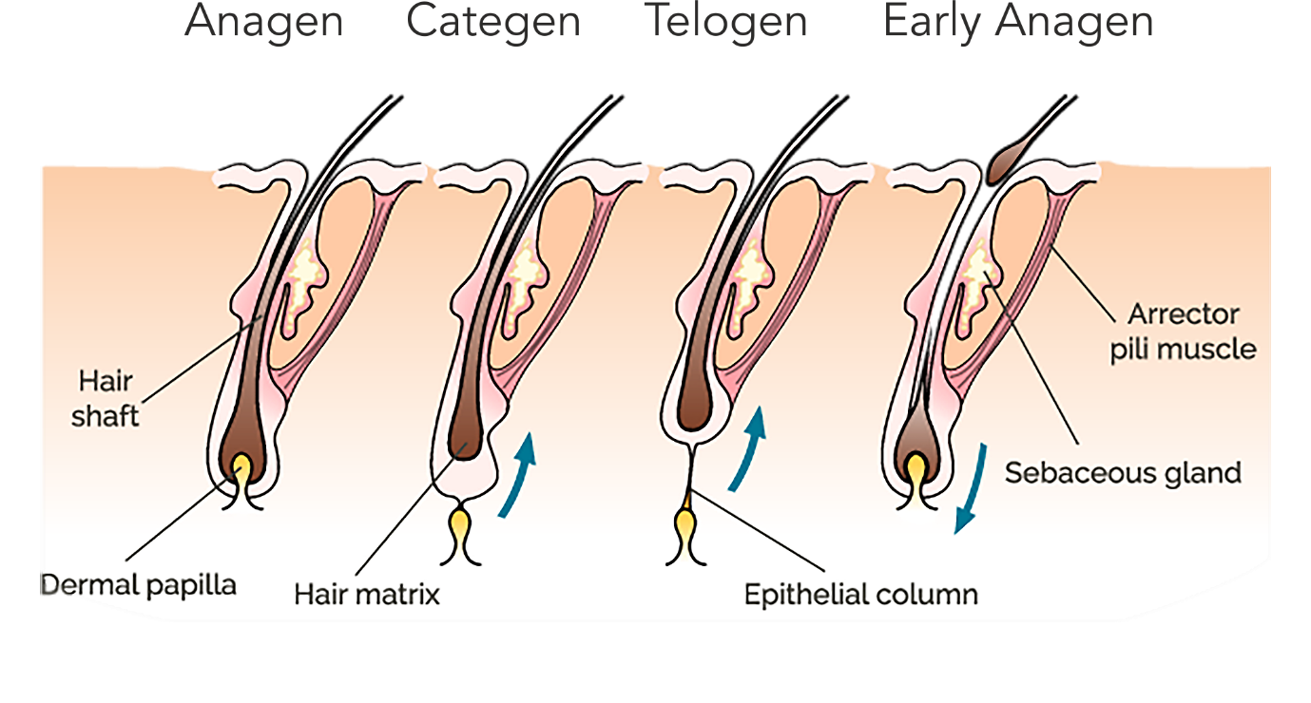
No one becomes bald because the hair is falling. You become bald because the hair cycle is interrupted and fallen hair is not replaced with new hair. The hair cycle should continue after telogen and restart, coming back to anagen. If the conditions are not favourable for rapid hair growth required to initiate anagen, then the follicle continues to remain in telogen. Gradually becoming chronic telogen with an extended empty follicle phase - kenogen.
You need three things to push the telogen hair to anagen -
1. Stimulation: You need to stimulate and wake up the hair to come in the growth phase by using scalp applications of peptides or minoxidil or stem cell extract or growth factors injections or PRP injections or Low Level Light Therapy - called Hair Laser or proven oils or serums.
2. Support with building blocks and fuel for the growing hair: You need to provide iron, calcium, amino acids which are building blocks for the new hair and provide antioxidants, vitamins, minerals which are the energy or the fuel for the rapidly growing cells. These elements also restore wellness in all the cells, improving cell functions. The nutritional supplements promote wellness, good health and hair growth.
3. Scalp hygiene: Good hair growth requires a clean scalp. Detox the scalp, have deep cleansing, open blocked pores, remove dandruff, oil, sebum, dirt, grime, pollution from the scalp and create healthy conditions for hair growth. Regular shampoo is required at least three times a week. If you have exposure to dust, dirt, pollution, travelling, gym, swimming, sweating, you need to shampoo the scalp every day. Clean hygienic, moisturized scalp with pH 5.2-5.6 is essential for hair growth.

Multiple causes for hair loss:
External Causes:
Smoking, Hookah,
Passive smoking,
Tobacco, Pan, Tea, Alcohol
Season, Humidity,
Pollution, Dust, UV rays
Electronic screens
Chemical fumes
Hard water
Change in time & food type
Stress, Lifestyle, Sleep
Physical exertion
Excess heat or cold
Dryness of the Scalp
Poor Scalp hygiene
Swimming,
Steroids, Fat Burners,
Ironing, Blow dry, Color
Hair products

Air Con environment
Pressurised Airline Cabins
Over use of Hair Products
Blow drying

Internal Causes:
Iron, calcium deficiency
Vit. A, C, E, D deficiency
Overuse of Vit. & Supplements
Thyroid hypo or hyper
PCOD hair loss
Metabolic changes
Siborrhoeic scalp
Prolonged illness
Emotional episodes
Pesticides, Chemicals in food
Crash Dieting, No Carb Diet
High Protein Diet
Fat free Diet, Keto diet
Poor fluid intake
Side effect of medications
MPHL, FPHL, DUPA
Post Pregnancy Hair loss
Post Menopausal Hair loss

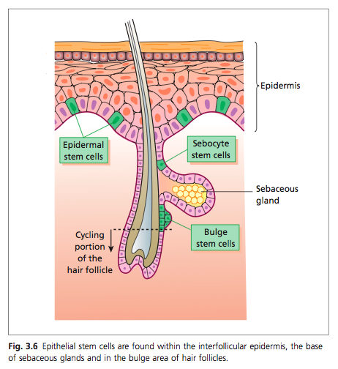

The traditional teaching is that hair loss occurs due to hereditary, family history and due to male hormones. This was more of a social observation rather than a concept derived from scientific evidence. There are no studies that can link hair loss to genes, chromosomes or raised hormone levels. Hair loss is seen to occur without any family history and in people with normal hormones.
There are various internal and external causes responsible for progressive thinning and baldness. Baldness is created by slowing down or arrest of hair growth rather than the number of hair falling. The causes suspected are vague, not well defined, not quantifiable or measurable, cannot be directly correlated and cannot be verified or confirmed with any tests. Reversing or fighting the cause for hair loss, does not give back the hair growth. We need to proactively follow a program to stimulate the resting, non growing hair and achieve good hair growth.
You treat hair loss from one cause, hair will fall for another cause. All people exposed to the same cause do not suffer the same hair loss. Every person staying in the city having hard water is not losing hair, every person stressed with the same work is not losing hair, every person who smokes or is exposed to pollution is not having the same hair loss. Not even all the hair on the scalp of the person having hair loss, is affected at the same time. Why are rest of the surrounding hair growing if hormones or genetics is the cause? You find that only weak roots are affected, other adjacent roots are still successfully fighting and managing to stand against the cause. Your hair roots are weak that is why they are being hit by the causes. The secret lies in strengthening the weak hair roots and making them strong enough to stand for any cause instead of trying to fight one cause after another. Strengthening the hair roots can be done with low dose nutritional supplements to deliver wellness, good health and hair growth.
Can you make hair loss zero?
Some hair will always fall. Body does not retain damaged hair. Hair that becomes weak, damaged, useless, will be thrown out by the body. This fallen hair should be replaced with new hair. When there is no replacement of the fallen hair and no regrowth, we gradually start thinning and become bald. Hair is not falling because there is something wrong with you. A basic set number of hair will always become weak from effects of the surrounding environment, pollution, uv rays, dust, smoke, humidity, stress, sleep, diet changes, climatic or seasonal variations. This basic percentage of hair that should be in fall phase, has increased due to exponential rise in pollution, lifestyle, stress, sleep disturbances, loss of nutrition in the foods and erratic climate change. Plus there is no support for creating new hair growth which is compounding the problem. At least 10% of the hair is always in fall phase. Losing 100-150 hair strands per day is normal. Hair loss, less than 15-20 hair per day, passes off unnoticed but hair loss is result of a biological cycle and cannot become zero.
Hair fall and Hair growth are two separate cycles
As soon as we see hair falling we feel that all the hair has stopped growing and all the hair will now just fall off. But hair fall and hair growth are two separate cycles. You can improve hair growth and grow more hair while some of the hair is falling. You have 1 lakh to 1.2 lakh (one hundred thousand to one hundred twenty thousand) hair on the head. If you lose 100-150 strands of hair per day which would total to 3000-4500 hair per month, it is just 3-4.5% of what you have. You can make all the remaining 95-97% hair grow better instead of crying your heart out for the 3-4.5% of falling hair. You should make sure more and more hair from the remaining 95-97% are not becoming weak and are waiting in line, ready to fall in the next cycle. Improving the strength and growth of rest of the hair is more important than fighting only the fall of a few hair. This can be achieved with a well planned nutrition and hair care program. Commercial advertising has made hair loss into a dreadful concern whereas we should be focusing our attention towards better hair growth more than just stopping hair fall. Stopping hair fall will make you look the same but adding new hair growth will make you look better.
How is nutrition affecting hair?
All growing cells in the body require good nutrition. Today we are in an era of ever rising nutritional problems compounded by over awareness leading to abuse and indiscriminate overuse of vitamins and nutritional supplements. The moment there is nutritional deficiency or imbalance the first organ to suffer is hair. As soon as you begin to get less nutrition the body decides priorities. The body feels that you can survive without a single hair on the head. Body shuts off hair growth and redirects the resources to the functioning of more important systems like heart, lung, liver, brain, kidney etc. Circulating levels of nutrients are maintained normal in the body by not making the hair. Hence even lab tests during this initial compensated state will show normal levels leading to wrong conclusions that blood levels are normal and hair fall is not related to any deficiencies. Using well planned low dose supplements is immediately seen to restore hair growth.
Nutritional problems are rising due to loss of nutritive value in the foods. Due to overharvesting, wrong agricultural practices, fast growing high yielding varieties of crops the grains, vegetables and fruits today contains 30-40% less nutrition than it had 50 years ago.
Restricted eating due to weight watching, preference for pleasure eating out of stress, wrong selection of foods and wrong timing for foods has resulted in low nutrient states defined as 'hidden hunger'. We are filling out stomach without meeting the nutritional needs. High quality foods termed 'income elastic protective foods' are available only to high income groups. There is a 'Adult Micronutrient Quality Index' defined to study malnutrition in adults. Hair bears the brunt of all these nutritional problems. A well planned nutrition and hair care program restores hair growth without use of harmful medicines. Hormone levels in hair loss patients today are normal and use of anti hormone treatments and enzyme blockers with harmful side effects is not required. Restoration of fundamental wellness is our primary responsibility.
Hair is a mirror of health
Hair growth for the body has always been optional. Hair follicle has a metabolic turnover comparable to bone marrow and intestinal epithelium. Even animals shed off their fur during summer when it is not required and grow it back in winter. Hair growth requires a balanced internal environment and a steady source of nutrition to support rapid cell division. Slightest imbalance in the body or loss of internal cell environment, immediately shuts off hair growth and redirects the available resources to restore function in more important systems. Hence we see severe hair loss called telogen effluvium after sickness, high fever, surgery, child birth, physical exertion, stress etc. In order to achieve hair growth it is required to ensure healthy functioning of all other systems in the body. This is our approach. Our goal is achieved through a well planned antioxidant, detox, anti stress, synergistic nutritional program that promotes wellness, good health and hair growth. Nutrition enriches the cells repairs the damage and restores hair growth.
Investigations and Laboratory tests in a Hair loss patient
CBC,
Serum Ferritin, Iron Saturation, Iron Binding Capacity,
Serum Protein,
Serum Cortisol,
Vitamin B12,
Vitamin D3,
Free Tesosterone
In Non Menopausal Women – FSH, LH,
DHEAS
DHT levels
Thyroid Function tests – T3, T4, TSH
Liver Function Tests
Hair loss often associated with Thyroid and PCOS
Just as hair growth requires a good source of nutrients so do all functions in the body. We say hair is a mirror of health. Often we find that female hair loss patients also have thyroid problems and poly cystic ovarian syndrome from improper secretion of hormones. Hormones are polypeptides, made up of basic amino acids. Vitamins, minerals, micro nutrients are required to act a catalysts, coenzymes to complete the process of creating hormones in the body. The secretion of hormones is therefore affected due to the nutritional deficiencies occurring in hair loss pateints . Correction of nutrition with Cyclical Nutrition Therapy often also improves their associated hormonal conditions.

Why Cyclical Nutrition?
Advantages of Cyclical Therapy over regular vitamins:
- Vitamin and nutrients have inter nutrient interactions which reduce the efficiency of one another. Therefore, multi vitamin capsules with all in one formula are ineffective. Too many nutrients administered together in high doses cause wastage of nutrients. We have studied which vitamins and nutrients are synergistic or complementing each other for better action and which are antagonistic or not compatible with each other, reducing the effectiveness. Cyclical Nutrition Therapy avoids antagonist or competing nutrients from being administered together. Cyclical Nutrition Therapy combines synergistic compatible nutrients that complement each other and help each other to work better.
- Cyclical Nutrition Therapy reduces the dose and increases efficiency of the nutrients and vitamins.
- Cyclical Nutrition Therapy achieves better benefit with lower dosage of the nutrients. Thus preventing unnecessary high doses and wastage.
- Cyclical Nutrition Therapy provides comprehensive correction of all micro nutrients, vitamins, minerals to enhance wellness and restore a balanced internal environment for optimum cellular functions.
- Cyclical Nutrition Therapy enriches individual cells to achieve wellness, good health and hair growth.
- Cyclical Nutrition Therapy uses once in three day dosage prevents over burden on the system. The once in three day regimen allows proper nutrient absorption, activation factors, binding, distribution, transport mechanisms, to be recharged and restored becoming available at their best capacity following a repeating cycle, every three days.
- Cyclical Nutrition Therapy uses nine different nutrient combinations every week to restore subclinical and covert deficiencies leaving no room for incomplete correction or chance of failure.
- Cyclical Nutrition Therapy uses once in three day dosage which prevents any possibility of overdose and hypervitaminosis to ensure safety over long term use.
- Cyclical Nutrition Therapy delivers benefit to all the body systems. Correction of aches and pains, experiencing better energy levels, better skin and nail along with better hair, correction of thyroid, correction of PCOD have also been reported by patients.
- Cyclical Nutrition Therapy uses the nutrients once in three days making them easy to assimilate and tolerate buy the gut, especially iron and calcium which may not be tolerated by some in a daily dose.
- Cyclical Nutrition Therapy offers low dose sustained correction of nutrients which is essential to compensate for the loss of nutritive value of the foods, cover deficiencies from wrong selection of foods, fad diets and compensate the growing tendency towards weight watching and restricted eating.
- Cyclical Nutrition Therapy utilizing nutrients once in three days making the program efficient and cost effective when compared to conventional trend of having all nutrients everyday on all seven days of the week.

Highlights of the Scientific Concept of Cyclical Nutrition Therapy:
1. Nutrition is good for health, but it is a misunderstanding that excess nutrition or excess consumption of supplements can lead to better health.
2. Excess nutrients can cause overload and burnout of the cellular systems, leaving them incapable of utilizing too many nutrients at the same time.
3. Absorption of nutrients, transport of nutrients, storage, conversion to active form all requires mediators, enzymes, catalysts and other micro nutrients creating rate limiting barriers to high doses. (eg. activation of folate).
4. No Nutrient can work alone. Iron requires Vit A, Vit C, copper, zinc selenium, magnesium. Calcium requires Vit D, Vit C, Vit K, magnesium, zinc to complete its actions. All nutrients are biologically interlinked in cellular metabolism, though we seem to study them separately.
5. Lack of nutrition is compensated by redirecting nutrients from less important optional functions as hair growth to the main circulation for maintaining vital functions. Hence majority of the times blood levels in lab tests turn out to be normal and the covet deficiencies remain undetected. We cannot wait till conditions become extreme and deficiencies are detected in circulation.
6. Lack of nutrients is compensated by autophagy and arrest of hair growth cycles. Hair follicles are storage sites for Ferritin, essential micro nutrients and energy, which are subject to retrieval in starvation and deficiency states.
7. Just as drugs have inter drug inter actions, the nutrients have favorable and unfavorable inter nutrient interactions. Nutrients can be synergistic to each other or completely antagonistic and competing with each other. Wrong combinations end up decreasing the bioavailability and efficacy of the nutrients. Multivitamin pills disregard nutrient synergism and antagonism creating impressive lists on the labels with no attention to lack of benefits from the combinations.
8. We have paired synergistic nutrients together and separated antagonistic nutrients to be administered on different days. Thus, advising different nutrients on different days of the week to reduce the dosage, prevent overdose and improve efficiency.
9. Due to loss of nutrition in the soil the crops, vegetables, fruits have been shown to contain 30-40% less nutrients than what was recorded 50 years ago.
10. High yielding verities of crops and fruits growing in lesser duration of time, do not accumulate the same content of nutrients and biological properties as regular growing varieties.
11. Use of pesticides, fertilizers, processing of foods, preservatives and taste makers laced in foods and food products act as Endocrine Disrupting Chemicals (EDC) leading to disorders of hormonal imbalance and metabolic disfunction.
12. Stress, competitive life, late night activity, exposure to bright lights, smoking, alcohol, poor eating habits, obsession for controlling weight are leading to early burn out causing previous age related disorders that manifested beyond the age of 45-55 years to appear today in youngsters as early as 25 -30 years of age.
13. There is good awareness for benefits of nutrition but it is high time we explain that there is a better way to have your supplements.

Introduction to some Trichology Conditions:
Alopecia by itself just means hair loss. There can be different types of alopecia.
Androgenetic Alopecia and Pattern Hair loss
The term Androgenetic Alopecia (AGA) was used in 1960 to define hair loss caused by two main factors, one was genetics, hereditary or family history and second being androgens or hormones out of which dihydrotestosterone DHT was the main androgen concerned. Today we know that hair loss can occur without family history and without any rise in DHT despite normal hormone levels. Researchers now do not call it androgenetic alopecia but prefer to call it Male Pattern Hair loss (MPHL) and Female Pattern Hair loss (FPHL).
Male pattern hair loss:
Begins as receding of the hair line and receding on the temporal regions to deepen into a 'M' shape gradually with thinning on the whorl area, crown which then meet together causing a bald area. MPHL is classified from grade I to grade VII.
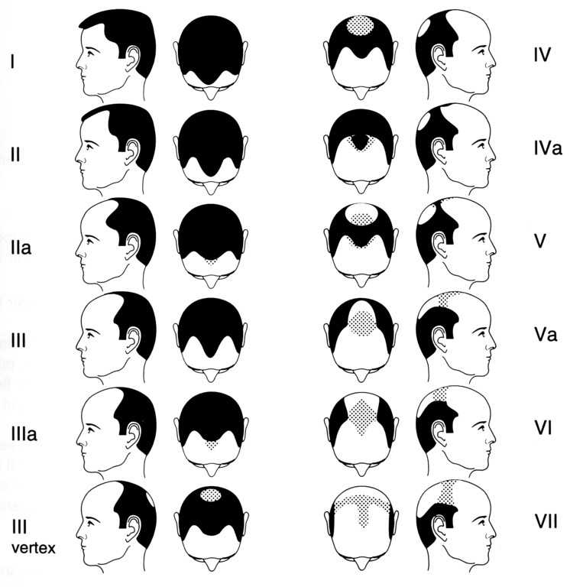
Female pattern hair loss:
Hair loss begins as thinning over the vertex and expands gradually to involve the scalp. Hairline is preserved in females. Main complaint is loss of volume, inability to style the hair which keeps hair falling flat. Most 2-3 hair units, get converted to only one hair growing in the unit. FPHL is classified into grades as per severity.
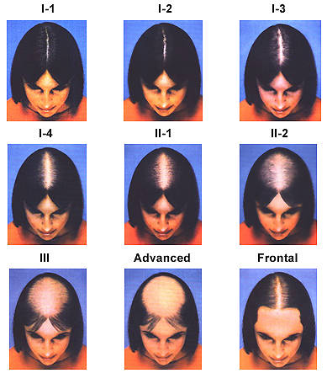

Diffuse Unpatterned hair loss:
Also called DUPA is hair loss occurring from all over the scalp without following any pattern.
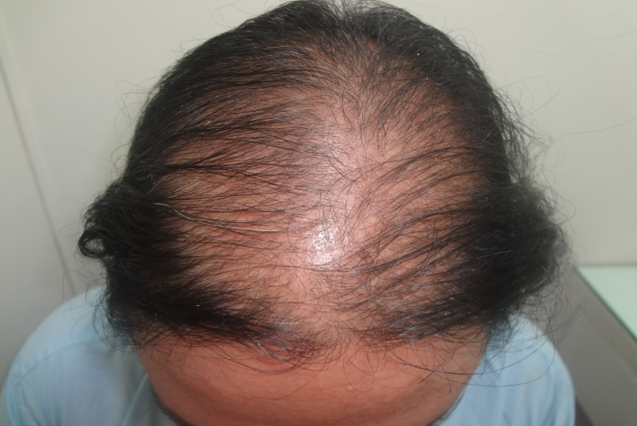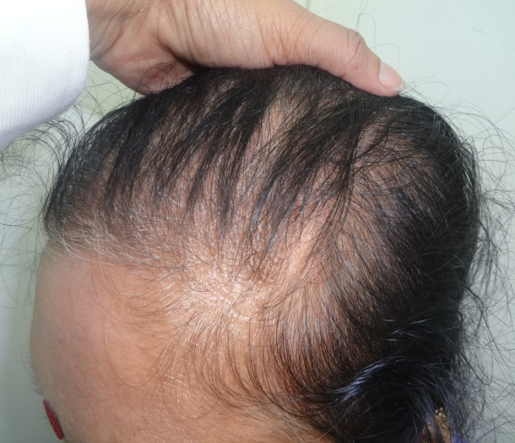
Reverse balding
Just as the front hairline recedes backwards, the hairline from nape of the neck begins to recede upwards which is described as reverse balding.

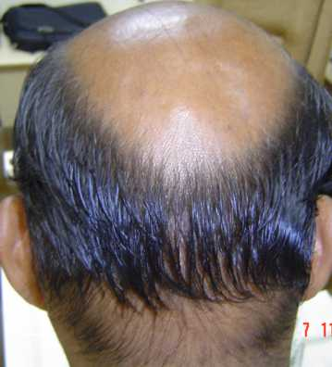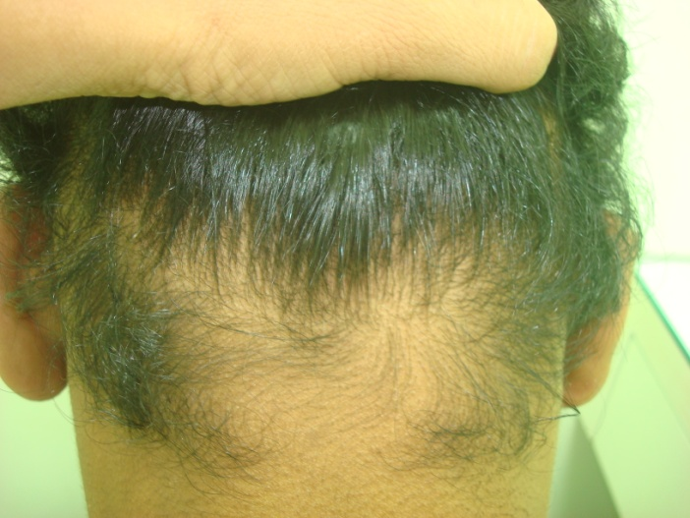
Telogen effluvium:
Telogen is the resting phase of the hair follicle which lasts for 3-4 months. Sensitive hair can change from growing anagen phase to a resting telogen phase due to factors like high fever, surgery, high dose medications, crash dieting, keto diet, fat free diet, high protein diet, exposure to extreme heat or cold, stress, physical exertion, use of chemicals on the scalp, exposure to pollution, UV rays etc. The change to telogen causing hair fall usually is seen 3-4 months after the triggering cause. You have to inquire about what happened over past few months. Sometimes hair can naturally come back to growth phase in the next 3-4 months if the causative factor is mild and not recurrent. This spontaneous recovery may happen irrespective of any application or treatment.
Acute Telogen effluvium is when hair loss is immediately seen after the effect of the causative factor. Hair loss due to acute telogen effluvium can be recovered with a well planned hair care program which includes, scalp application (hair stimulation) and oral supplements.
Chronic Telogen effluvium describes continued hair loss occurring over prolonged period of time. The causative factor is recurrent, there is repeated, continuous exposure to the damaging agents. The hair damage may be very gradual, slow, causing micro inflammation over several months building up into severe progressive hair loss. In some cases the damage when left uncorrected can progress in severity and inflammation, leading to one of the types of scarring alopecias.
Traction Alopecia:
Traction Alopecia occurs with tight hairstyles causing a pull back or traction on the hair roots. a fringe of thin fine villus or partially growing hair can be seen along the front hairline. Change of hair style may help in very early cases. Hair loss due to traction alopecia, can be recovered with a well planned hair care program which includes, scalp application (hair stimulation) and oral supplements. Chronic long standing traction alopecia causes scarring in the skin which then makes it difficult to regrow the lost hair.
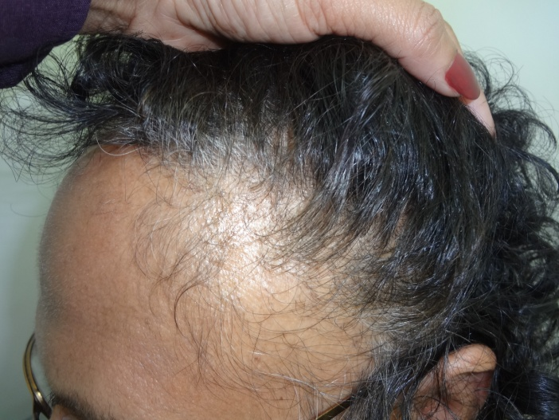

Turban Alopecia:
Turban Alopecia is seen commonly in Sikh community due to wearing tight turbans since childhood. The only treatment is hair transplant which often requires two or more stages for good density.
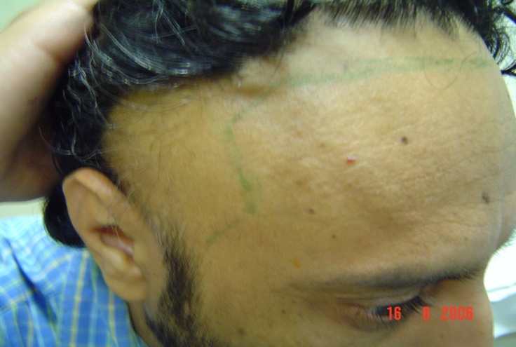
Alopecia Areata:
Alopecia Areata is a autoimmune disease where the persons own body defence system begins to attack its own hair follicle due to a misunderstanding that they are foreign antigens. Alopecia Areata has a mind of its own. The disease will increase of decrease at its own free will. There can be complete spontaneous remission especially in children. Treatment is local steroid injections and applications over the affected areas. Recurrence is common. Strengthening of rest of the hair roots and building up patients immunity can be achieved with a well planned hair care program which includes, scalp application (hair stimulation) and oral supplements.
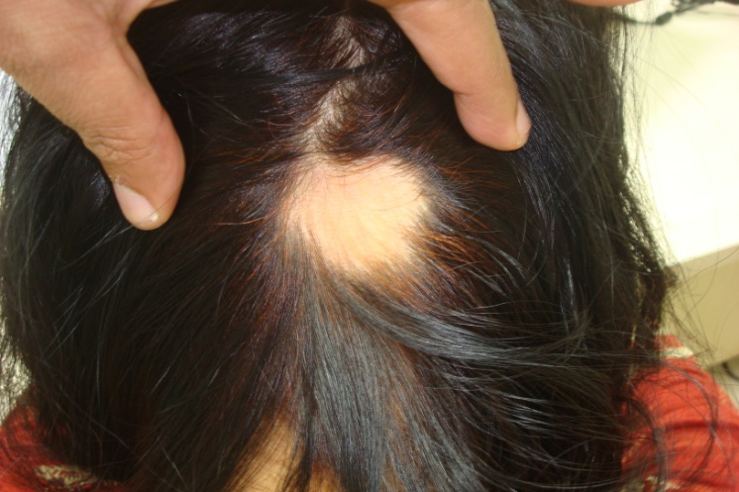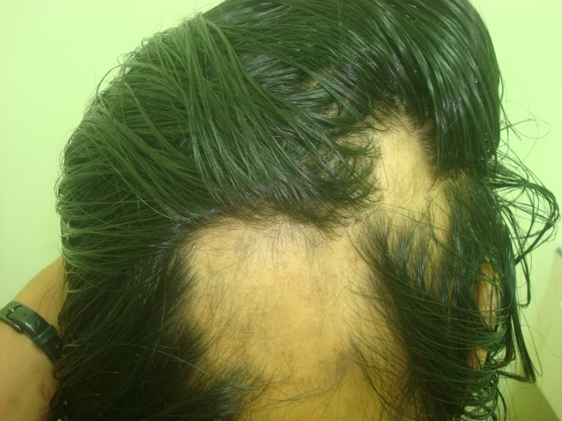
Alopecia Areata can occur as single (monolocularis) well defined rounded patches of hair loss. Adjacent hair can be easily pulled out in active disease. There can also be multiple areas of hair loss over the scalp (multilocularis) or over scalp, beard, eyebrows and eyelashes called Alopecia totalis. Involvement of scalp, beard, eyebrows, eyelashes plus body hair is called Alopecia Universalis. Trials of recent research with JAK inhibitors are expected to be effective in treating Alopecia Areata.
Ophiasis is Alopecai Areata seen like a wave or snake like pattern along the circumference of the head involving nape of the neck, over the ears, temporal areas and the hairline, leaving the central part unaffected. Reverse pattern is called Sisaphio.
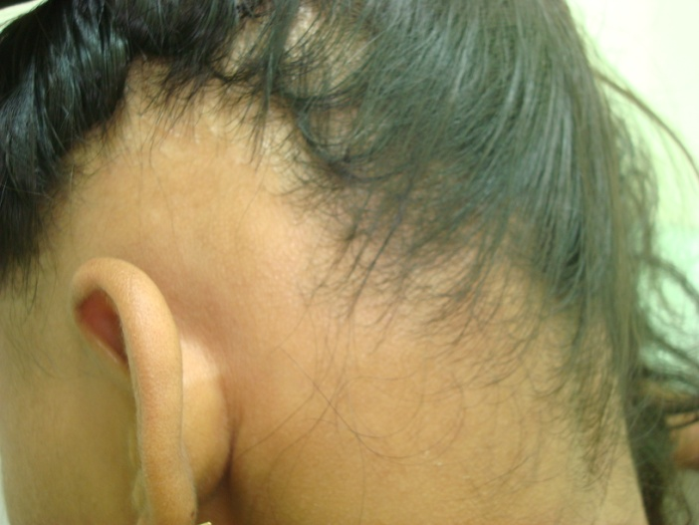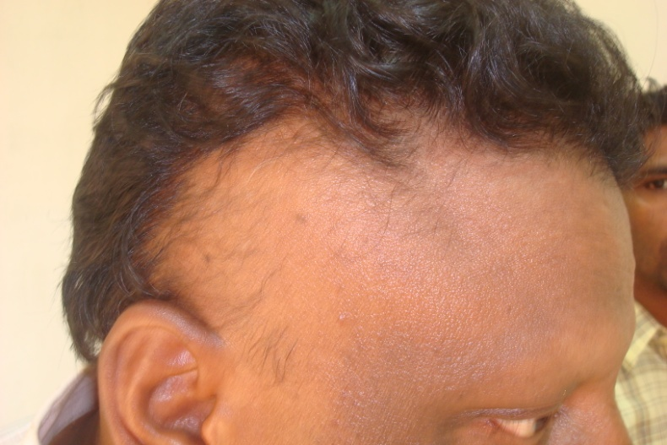
Scarring Alopecias:
CCCA Central Centrifugal Cicatricial Alopecia is a scarring alopecia seen in Afro American women. Occurs commonly in post menopausal women. It begins as hair loss in the mid vertex of the scalp and gradually spreads like a widening circular area. Scalp inflammation may be seen. Arresting further spread and regrowth can be achieved with steroids and a well planned hair care program which includes, scalp application (hair stimulation) and oral supplements.
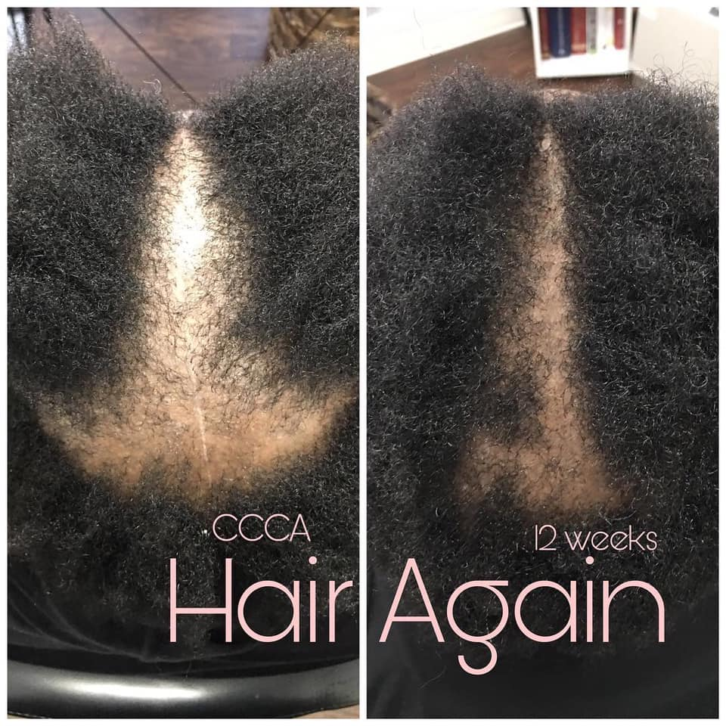

Pseudopilade of Broq:
Pseudopilade of Broq is scarring alopecia with areas of hair loss between normal hair. Treatment of scalp inflammation is required in early stages.
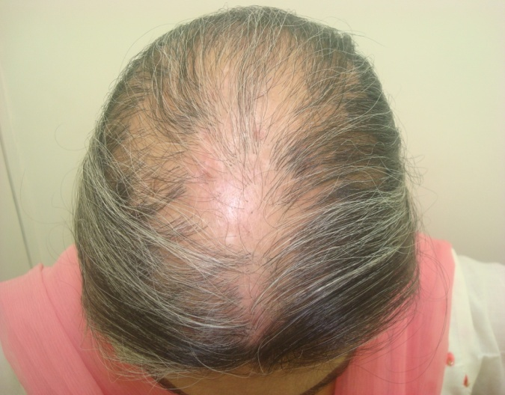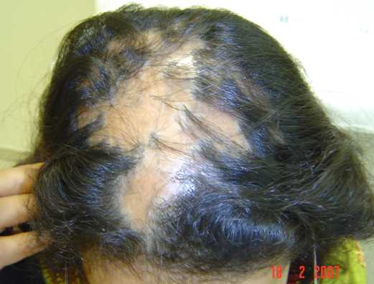
Folliculitis Decalvans:
Folliculitis Decalvans or Tufted Folliculitis is a scarring alopecia that begins with inflammation, pain, itching, swelling, multiple hair coming out of dilated follicles with perifollicular keratosis, seen as white circular dry margins around the follicles. Treatment for staphylococcal infection and inflammation may be required in early stages.
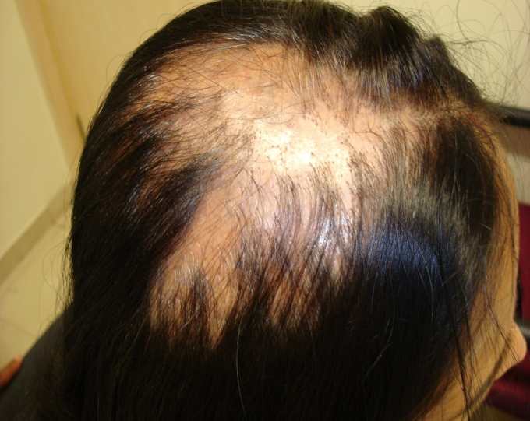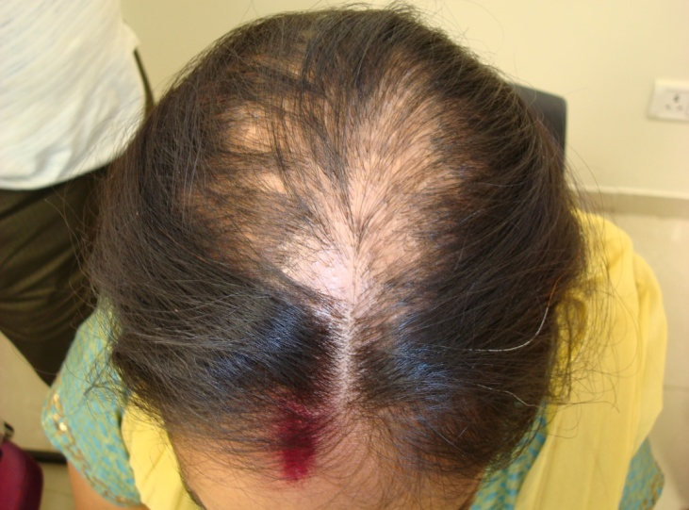
Lichen Plano Pilaris or LPP:
Lichen Plano Pilaris or commonly known as LPP is Lichen planus disease affecting the scalp. It causes intense itching, burning, pain, tenderness with patches of redness, scaling of skin around the base of the follicle, blocking the hair follicle. It results in scarring and hair loss. Common in women, poor immunity is suspected to be a cause.
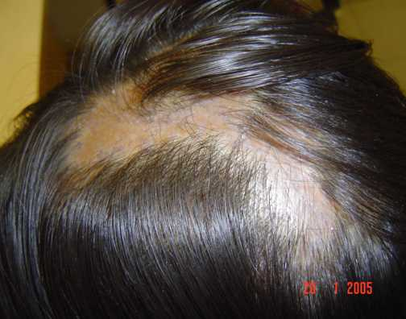
Frontal Fibrosing Alopecia or FFA:
Frontal Fibrosing Alopecia is a scarring alopecia that commonly but not exclusively affects post menopausal women. Now seen to be rising in incidence. Causes band of recession along the frontal hair line with no signs of villus hair. It affects temporal hair and eyebrows as well.
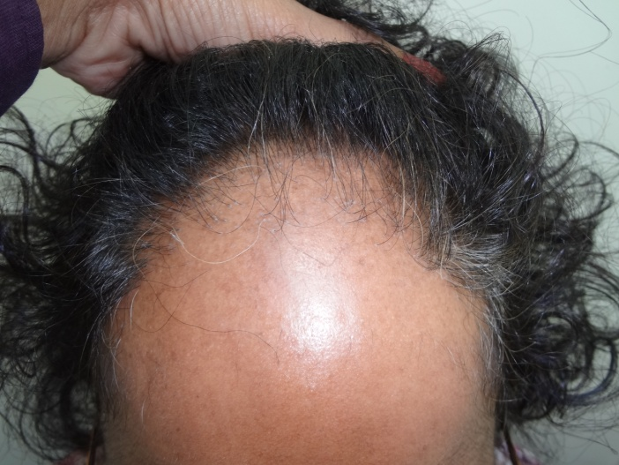
Treatment strategy for all scarring alopecias
Hair transplant can be effective after the disease is inactive. Strengthening of rest of the hair roots, improving hair growth of the remaining hair, reducing inflammation and building up patients immunity can be achieved with a well planned hair care program which includes, scalp application (hair stimulation) and oral supplements.
Other Alopecias to note

Diffuse Alopecia Areata - areas of alopecia areata spread all over the scalp with normal hair growth in between. Can appear like pattern hair loss.

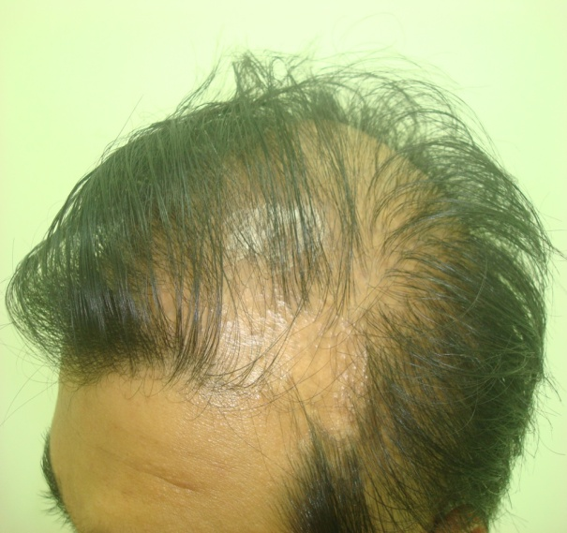

Woolly Hair Syndrome - Weak curled woolly hair by birth. Hair quality thickness and caliber can be improved by scalp applications and Cyclical Nutrition Therapy.

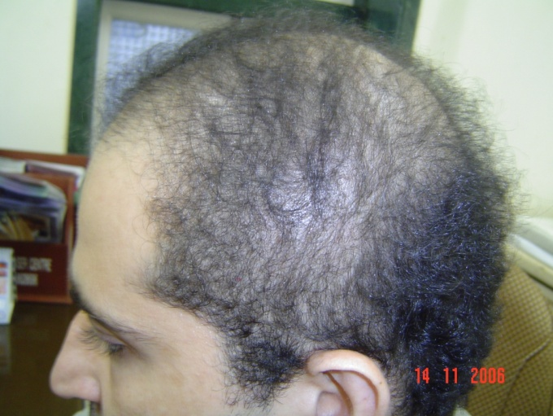

Short Anagen Syndrome - short slow growing hair in children which does not grow beyond certain length. Responds very well to scalp applications and Cyclical Nutrition Therapy.

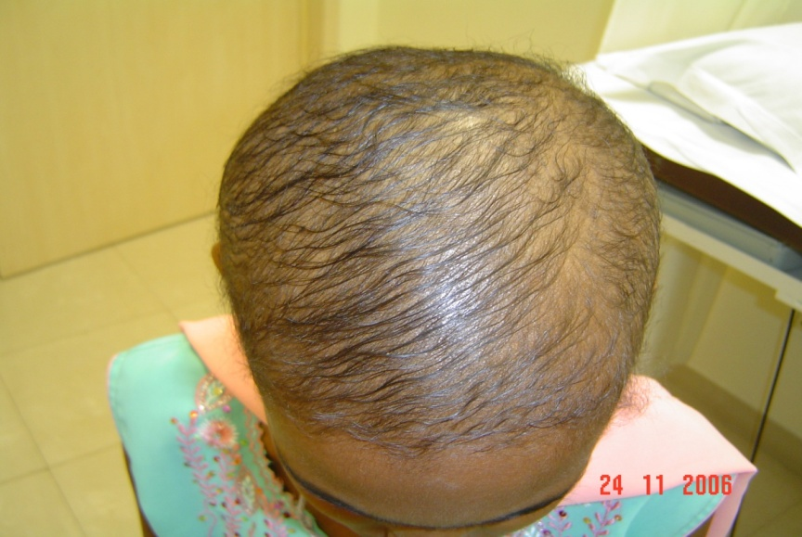

Loose Anagan Syndrome - Common in children and teenagers. Hair is loose and gets easily pulled out. Hair roots can be strengthened to improve the condition by using scalp applications and Cyclical Nutrition Therapy.

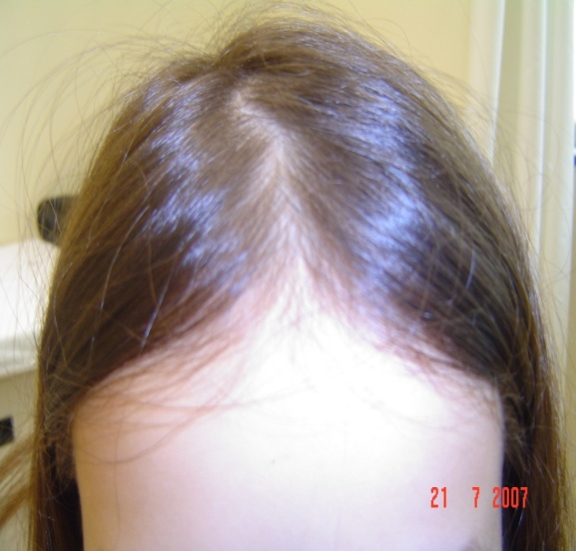

Hair Transplant

You are born with two kinds of hair roots. Sensitive or temporary hair roots on the front and top of the head while long lasting less sensitive roots on the sides and the back of the head. In hair transplant we borrow roots from the long pasting areas and transfer them to the areas of hair loss. With the latest FUE, Follicular Unit Extraction technique we can use beard hair, chest hair and upper abdomen hair as well. Good hair care is required before and after hair transplant. Success rate in properly done procedure with experienced team is over 90%.

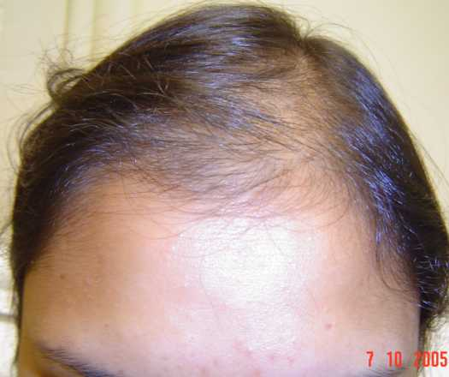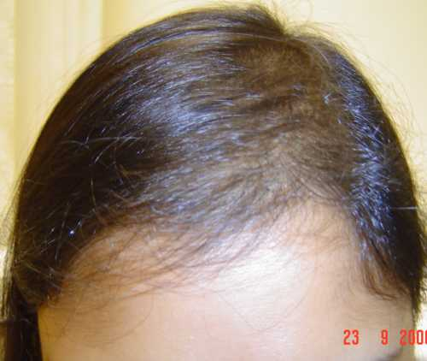

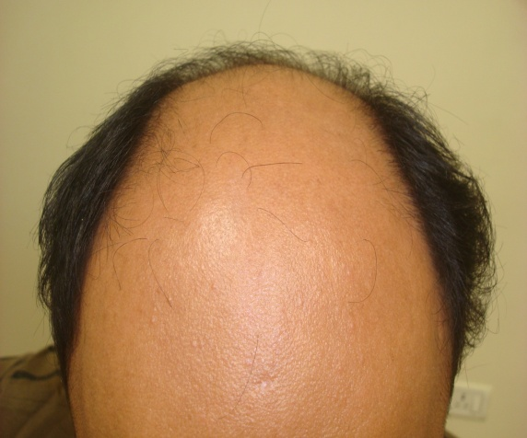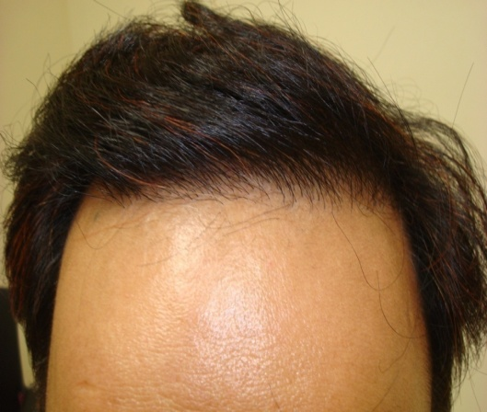

Dandruff
What is dandruff?
A few million body cell from outer layer of the skin shed every day. These dead cells stick to form clumps presenting as dandruff. Oily secretion of sebum from the scalp, is broken down to fatty acids and triglyceride, oleic acid by Malassezi yeast also known as Pitryosporum ovale and failure to wash off this accumulation, binds along the dead cells to form flakes or oily dandruff. Oleic acid causes easy separation and shedding of the stratum corneum skin layer cells further increasing the exfoliation. Dandruff can also occur from excessive shedding and dead cells reacting with sweat, without rise in oily secretions, which appears as dry white powder, recognized as dry dandruff.
Dandruff propagates a vicious cycle. Once there is dandruff, it causes itching, leading to nail scratching and injury to the outer protective layer of the skin, this breaks the protective layer allowing easy penetration to more organisms and inflammation leading to more irritation and more dandruff. Dandruff can occur over other oily or hairy areas like chest, eyebrows, nose, beard & ears.


Dandruff is caused & triggered by – oily scalp, excessive sweating, infrequent washing, poor scalp hygiene, yeast and fungal infections, irritation of the scalp to pollution, chemicals, fumes, soaps, shampoos, hair products, gels, sprays, alcohol containing lotions, applied medications, sweating, high humidity, extreme weathers, exposure to sunlight, excess heat or cold, air conditioner blowing on the scalp, continuous AC environment has effect of VOCs volatile organic compounds in the AC atmosphere. People staying or working around construction areas with dust, dirt, cement blowing in the air, frequent commuting with suspended particles and wind blowing in the hair lead to dandruff. Frequent washing and pre oiling or using leave on serum can protect the hair. Emotional and mental stress, fatigue, affect oil and sweat glands creating dandruff. Dandruff may not be hereditary, but the habits and lifestyle followed in the same family may affect entire family in the same way causing dandruff. Dandruff as such is not contagious but the fungal and yeast infection may be transmitted by contact and sharing unclean combs or towels. Neurological diseases, stroke, low immunity diseases, chronic illness and obese patients have dandruff.
Treatment
Dandruff is like sweating, it is a apart of the body function to shed off cells. We cannot make dandruff zero, it can be controlled or reduced. We can prevent associated fungal infection and irritation. Best way to keep dandruff away is to wash regularly. Regular use or daily use shampoo is good. You do not need anti dandruff or anti fungal shampoos unless you have infection. If you find redness, unstoppable itching, irritation, burning, pain in the hair roots, thick flakes of dandruff not responding to regular shampoos, it is time to consult your doctor.
The correct way to use scalp cleansers and anti dandruff shampoos is to wet the hair, massage the shampoo into the roots, leave it for 3-5 minutes and then wash. This allows time for action of the treating agent. For inflamed scalp earlier use of cortisone creams, lotions is now replaced by better option of non-axis locally acting agents like 0.01% Fluocinolone lotions & prescription shampoos. Effective remedies 2% Ketconazole is antifungal (keep away from 1% is not effective). For resistant fungal infection Ciclopirox is newer alternative. Cotrimazole and Piroctone olamine are other anti fungals. Coal tar can reduce excessive shedding of cells. Zinc pyrithione called ZPT / ZPTO regulates sebum production, keratinization and reduces the yeast as well. Selenium sulfide is effective in reducing sebum. Milk of magnesia local application is an old effective remedy.
Natural remedies – twice a week for 30-60 minutes
Aloe vera, Tea tree oil, Coconut oil, Olive oil, Avocado extract, Fresh curd or lime juice for flaky dandruff.
One part white vinegar with 4 parts of water also helps to cleanse the scalp and prevent dandruff.
Phototherapy
Natural and artificial UVA, UVB radiation, red and blue LED Light curbs growth of Mallassezia yeast, reduces sebum and inflammation. Modern treatment is Low Light Laser Therapy for 20 minutes once or twice a week.
Diet for dandruff control
Avoid fried foods, sugar based foods, artificial flavors, additives, preservatives, regular meat, agino moto in Chinese preparations. This reduces activity of the oil and sweat glands, reduces post meal rise in androgens and promotes healthy scalp.
Add enough water 8-10 glasses to hydrate the scalp, 2 fresh fruits, greens, salads, turn by turn sprouts, chick peas, mushrooms, cottage cheese, tofu, all kinds of dals, beans and one green leafy vegetable a week.
Nutritional Supplements
Probiotics, Vitamin, B2, B3, B6, B7 (Biotin), Zinc, antioxidants to fight formation of free radicals and peroxides in the scalp. Adequate sleep, good breathing exercise which improves blood flow to the scalp can help in having better scalp health.
Short hair cut – reduces build up of humidity, inhibits yeast, allows air and sun light, makes easy to wash care and manage the hair till you tide over the problem.

Why does one get redness itching and scabs or crusts?
Fungal infection causes itching. Repeated scratching and irritation with the nails causes redness and injury. Injury invites bacterial infection, which causes hairloss. The injury heals with scabs and fibrosis, which again causes hairloss. Dry, dead, exfoliated skin trapped in the hair causes the crusts or shiny flakes that fall off when you scratch or comb or handle, the hair. This could be due to improper cleaning or excess formation of dandruff.

How can dandruff cause hairloss?
Dandruff is extremely annoying. It causes social embarrassment and can lead to scalp infection and hair fall. Fungal infection and /or low grade bacterial infection then, warrant antibiotics, capsules and scalp lotions. Infected glands and hair roots heal with fibrosis, which strangulates the blood supply and results in hair fall. In severe cases or with repetition of this cycle the hair loss becomes permanent.

Role of Diet in Hair loss
Masumi Inaba of Japan has shown a cause and effect relationship between the diet and the severity of hair loss through documentation and scalp biopsies. We advice our patients to avoid fried foods, bakery foods and red meat to reduce the over activity of oil and sebum glands, as these are the sites for 5AR enzyme activity and hyperactive glands may lead to more formation of DHT. It also reduces the accumulation of free radicals which are unfavourable for rapidly dividing cells.
Next is to avoid sugar based foods, as chocolates, pastries, sweets, (some sugar in tea or coffee is permitted). Increased sugar leads to insulin release, which in turn causes release of testosterone from its binding protein and makes it available for conversion to DHT.
Foods with artificial flavours, taste makers, additives, preservatives, colas are avoided as these chemicals lead to formation of free radicals in the body. Juices are best avoided for their fruit sugar, better is to eat fruits along with the fruit skin. Nutrients and vitamins in the fruit are concentrated just below the fruit skin, pulp contains only fructose and water. Having fruits with the fruit skin provides fibre and nutrients.
Fast foods and junk foods are avoided for lack of nutrition, use of chemical flavouring agents, additives and preservatives. Chinese foods made with aginomoto MSG can adversely affect hair.
Including variety of protein sources and antioxidants, like steamed sprouts, green vegetables, salads, all kinds of beans, pulses, mushrooms, cottage cheese, chick peas and nuts can improve hair growth still reducing the ill effects of meat.
Vitamins are of two kinds water soluble and fat soluble Vit A, D, E, K. Adding a spoon of ghee or a slice of cheese can provide the fat soluble vitamins required for the bounce and lustre in the hair. Strict no fat diet makes the hair dry, lifeless and falling flat. Also having 12 glasses of water in a day maintains skin hydration and prevents dryness.
One of the theories for hair loss is the reduced blood flow or ischemia theory. Avoid smoking if you are loosing hair, it will constrict blood flow to the hair roots inducing ischemia leading to hair loss. Smoking also causes accumulation of free radicals which are harmful to growing hair roots.
Diet Modification to improve hair growth
Hair cycle consist of anagen, catagen and telogen. After telogen the hair follicle has to come back into anagen, for which sudden rapid cell division is required at a high rate. If body environment is not suitable for this rapid cell division, the hair roots remain in a dormant or resting phase. Telogen is a phase to conserve the hair follicle and regrow them later under favourable conditions. When conditions do not improve the hair suffers chronic telogen.
Diet and nutrition play an important role in hair growth. The metabolic turnover of hair follicle cells is second only to bone marrow and intestinal epithelium. Rapid cell division and growth requires a toxin free environment and supply of good nutrients to support the rapidly dividing cells. Food consumption today is irregular, at odd hours, against body rhythm or cycle. Food consumed is against local climatic, regional or seasonal preferences. The nutritive value of food has reduced. The nutritive value of soil itself has reduced.
The food consumed today is no more natural it is man made and modified. Yield is increased by using artificial chemicals, hormones, insecticides, fertilizers. Chicken are force fed keeping lights on at night to make them feel it is day time. Residues of antibiotics, anti helminthics, vaccines injected into ensure disease free rapid growth, are consumed by us with the meat. High protein diets favoured by fitness experts are also called the acid ash diets. These create acid during their metabolism, cause the blood to become acidic leading to reabsorption of iron, calcium into blood to counter the acidity. There is increase in the urea nitrogenous waste from high protein consumption, accumulation of these metabolic toxins makes internal body environment unsuitable for rapid cell division and hair growth.
Masumi Inaba of Japan has shown a cause and effect relationship between the diet and the severity of hair loss through documentation and scalp biopsies. We advice our patients to avoid fried foods, bakery foods and red meat to reduce the over activity of oil and sebum glands, as these are the sites for 5AR enzyme activity and hyperactive glands may lead to more formation of DHT. It also reduces the accumulation of free radicals which are harmful to rapidly dividing cells.
Next is to avoid sugar based foods, as chocolates, pastries, sweets. Increased sugar leads to insulin release, which in turn causes release of testosterone from its binding protein and makes it available for conversion to DHT.
Foods with artificial flavours, taste makers, additives, preservatives, colas are avoided as these chemicals lead to formation of free radicals in the body. Juices are best avoided for their fruit sugar, better is to eat fruits along with the fruit skin. Nutrients and vitamins in the fruit are concentrated just below the fruit skin, pulp contains only fructose and water. Having fruits with the fruit skin provides fibre and nutrients.
Fast foods and junk foods are avoided for lack of nutrition, use of chemical flavouring agents, additives and preservatives. Chinese foods made with aginomoto MSG can adversely affect hair.
Including variety of protein sources and antioxidants, like steamed sprouts, green vegetables, salads, all kinds of beans, pulses, mushrooms, cottage cheese, chick peas and nuts can improve hair growth still reducing the ill effects of meat.
Vitamins are of two kinds water soluble and fat soluble Vit A, D, E, K. Adding a spoon of ghee or a slice of cheese can provide the fat soluble vitamins required for the bounce and lustre in the hair. Strict no fat diet makes the hair dry, lifeless and falling flat. Also having 12 glasses of water in a day maintains skin hydration and prevents dryness.
One of the theories for hair loss is the reduced blood flow or ischemia theory. Avoid smoking if you are losing hair, it will constrict blood flow to the hair roots inducing ischemia leading to hair loss. Smoking also causes accumulation of free radicals which are harmful to growing hair roots.
You could count many friends who do not follow any diet or Lifestyle modification but have nice growing hair. Please remember, that they are born with a different type of hair. If you are losing hair you must follow these guidelines. We do not ask you to stop your favorite foods but to restrict them in frequency and quantity. Do not restrict to one kind of food choice, give all foods a chance to provide you all the variety of nutrients.

DIET ADVICE (INDIAN)

List of Foods to Avoid
- Mutton, Red meat, Fish Fry, Chicken. Two pieces cooked without frying avoid the gravy.
- Two eggs not more than two to three times a week.
- Coconut gravy, groundnuts or peanuts, excess potato, pasta & noodles.
- Fried foods – wada, samosa, puri, papad, dosas, chips etc.
- Sugar foods – chocolates, pastries, cakes, ice cream, sweets, desserts etc.
- Bakery foods – biscuits, toasts, khari, puffs, patties, rolls, croissants, doughnuts, cup cakes etc.
- Chinese foods – agino moto or Chinese salt is bad for hair.
- Fast foods – Pizzas, Burgers, Canned foods.
- Colas, Coke, Pepsi, soft drinks & all kinds of Juice.
- Strictly NO SMOKING

List of Foods to Add in your Diet
- Steamed Sprouts – 2 times a week,
- Green leafy vegetables – 2 times a week,
- Green Beans – 2 times a week, like Gavar, Chawli, Wal, Papdi, French Beans, broad beans, Ghewda.
- Raw Salads – Radish, Beet root, Carrot, Cucumber, Tomato, etc. cut and add salt, pepper, a dash of lime, no mayonnaise, no salad dressing, no sauce.
- Dry beans like Rajma, black beans, yellow beans, kidney beans – twice a week.
- All types of dals – black dal, yellow dal – turn by turn – daily.
- Mushrooms, Paneer (Cottage Cheese), Chola (Chick peas), Soya, Tofu – each - once a week.
- 4 – Walnuts / 4 – Almonds on alternate days.
- 1 – glass milk per day or a bowl of Curd or Yogurt.
- 1– tsf ghee per day or 1 – slice of cheese per day.
- 4 Fresh Fruits per day – cut & eat, with the fruit skin – fresh juice within 20 minutes.
- 10 – 12 glasses of Water per day, especially while flying and during night shifts.

DIET ADVICE (WESTERN)

List of Foods to Avoid:
- Avoid Chicken, you can have it not more than twice a week. Prefer grilled.
- Beef, Pork, Lamb, Fish, Sea food any of which not more than 2-3 times a week.
- void Potato, Pasta, Cream and melted cheese not more than twice a week.
- Avoid Chips, Fries, Tortillas, Nachos, Doritos, Processed foods and snacks.
- Avoid Sugar foods – Chocolates, Pastries, Cakes, Ice cream, Desserts etc.
- Avoid Colas, Coke, Pepsi, soft drinks & all kinds of Pre packed Juices.
- Avoid Bakery foods – Biscuits, Puffs, Rolls, Croissants, Doughnuts, White Bread.
- Chinese foods – agino moto or Chinese salt is bad for hair.
- Fast foods – Pizzas, Burgers, Canned foods
- Restrict Alcohol to two Beers or two Hard drinks 2 - 3 times a week.
- Coffee and tea are restricted to 2 -3 cups a day.
- Strictly NO SMOKING, Keep away from second hand smoke as well.

List of Foods to Add in your Diet:
- Steamed Sprouts 2 times a week,
- Green leafy vegetables 2 times a week,
- Lima Beans, Fava Beans, French Beans, Broad beans, Colored Beans, Black Beans, Kidney Beans - rotate the choice - 3 times a week.
- Salads with one meal everyday – Beet root, Carrot, Cucumber, Tomato, Greens, add salt, pepper, a dash of lime, no mayonnaise, no salad dressing, no sauces.
- Cottage Cheese, Chick peas, Tofu, Mushroom, Lentils - rotate the choice - 3 times a week.
- 10-12 Non Salted Walnuts, Almonds, Nuts everyday by rotation. Avoid Peanuts and Cashew nuts and Macadamia nuts.
- Low fat dairy products, slice of cheese, olive oil dressing - 3 times a week.
- Two Fresh Fruits per day – cut & eat, with the fruit skin when possible. Freshly squeezed juice can be consumed within 10-15 minutes.
- Have 2 - 3 cups of green tea or hot water every day.
- Have 3 - 4 liters of water every day.
- Have a Balanced diet Avoid High Protein Intake, Regular Whey Protein and extreme diets.

Hair Fact – Folliclular Advance Cyclical Therapy – FAQs
1. Is it safe to have HAIR FACT in Diabetes, Blood pressure, Cholesterol, Kidney disease, Thyroid, PCOS?
Ans: HAIR FACT has no sugar. HAIR FACT does not contain any medicines or drugs. HAIR FACT can be safely used along with any medication. HAIR FACT improves the internal cellular environment, improves cell function and improves the outcome of your existing treatment. Your disease control and disease status will improve with hair fact. HAIR FACT has no drug interactions with any other medical treatments. Since HAIR FACT delivers wellness at cellular level, it will improve the response and outcome of all other treatments. You can consult your doctor about adding this program using different tablets twice a week, as a low dose once in three days cycle.

2. Can I take HAIR FACT if I'm already on multi vitamins should I stop the multivitamins?
Ans: Yes HAIR FACT can be taken with your present multi vitamins. You can have vitamins in case of known deficiencies. If you are having vitamins only for wellness. You will now need lesser multivitamins. HAIR FACT will provide wellness along with hair growth. You can reduce the dose or frequency of the vitamins. Have HAIR FACT & vitamins at different times of the day. HAIR FACT in the morning and vitamins in the evening.

3. Why should I take this over the multivitamins which is better?
Ans: Using a single multivitamin with a all in one formula causes inter nutrient interactions. Too many vitamins, minerals, amino acids taken together reduce the efficiency of one another. HAIR FACT is a unique therapy that utilizes different nutrients on different days which reduces the dosage while improving the efficiency allowing complete utilization and benefit of individual nutrients on different days. HAIR FACT prevents wastages by avoiding dumping of too many nutrients on the cells at the same time. Hair fact is planned Cyclical Nutrition Program of organic nutrients ; is preferred over common multivitamins. HAIR FACT delivers wellness good health and hair growth.

4. Pregnancy ? lactation ? Safe to take or not
Ans: Consult your Gynaecologist during pregnancy and lactation. These events are more important while hair growth is secondary.

5. I have finished chemo for cancer. Can I follow HAIR FACT .
Ans: Certain nutrients are contraindicated after cancer treatments for hormonal cancer. Consult your doctor about adding this cyclic wellness program using different nutrients twice a week, as a low dose once in three days cycle.

5. Can I use HAIR FACT after Bariatric surgery?
Ans: After Bariatric Surgery the quantity of food intake is restricted taking a toll on your nutrition. You should include a nutrition care program after the surgery. HAIR FACT is best suited to provide low dose organic nutrients in a low dose comprehensive balanced program. HAIR FACT improves the internal cellular environment, improves cell function and improves the outcome of your existing treatment. Your disease control and disease status will improve with hair fact. You can consult your doctor about adding cyclical nutritional wellness program using different nutrients twice a week, as a low dose once in three days cycle.

6. I am suffering from severe hair loss ? Is it for me ?
Ans: HAIR FACT is specifically formulated to reduce hair loss. You will see improvement in 3-4 weeks. Hair loss changes with season, humidity, stress, diet, sleep cycles, pollution, UV rays. The external factors cannot be controlled. Minimal hair loss is still expected but it will be within accepted limits. The main benefit is fallen hair will be replaced with new hair and there will not be thinning, hairless areas seen with regular use of HAIR FACT and scalp applications.

7. I have no hair fall but my hair is generally thin . Will this make it thicker ?
Ans: Yes HAIR FACT can give thicker hair within 2 months. The hair quality will further improve every two months as you continue the therapy along with scalp applications.

8. I have dandruff issues ? Will this help me ?
Ans: Dandruff requires scalp care along with HAIR FACT. The scalp condition, oiliness, pH will improve with HAIR FACT.

9. Does this product help with greying hair?
Ans: Results in greying are 50-50. Greying today is more from multiple factors, pollution, UV rays, stress, nutritional deficiencies, toxin accumulation etc. HAIR FACT improves the health of the hair which is expected to correct the greying. The benefit in greying however is not as assured as much as hair growth with HAIR FACT .

10. I have a lot of split ends . Will this help ?
Ans: Split ends are due to weak hair shaft structure. HAIR FACT will strengthen the hair shaft and prevent split ends.

11. Hair breakage ? Will this help
Ans: Hair breakage is due to weak structure of the hair shaft, cortex. Commonly seen with iron, calcium and amino acid deficiencies. HAIR FACT will strengthen the hair and prevent breakage.

12. I am already on weight loss treatment ? Should I still take this.
Ans: Weight loss programs tend to cause hair loss. Controlled calorie intake in weight loss leaves the hair weak. HAIR FACT improves the internal cellular environment, improves cell function and maintains wellness during the weight loss program. HAIR FACT will provide organic nutrients to strengthen the hair and prevent hair loss during your weight loss program.

13. I have a family history of hair loss . It's hereditary. Will this help ?
Ans: Hereditary only means you can suffer hair loss more easily than others. You require early treatment for prevention, in time. HAIR FACT will strengthen the hair roots and promote hair growth allowing you to maintain your hair in case of family history or hereditary hair loss. Please start your hair care early.

14. I am on a intermittent / keto diet . Will this help me still with hair loss ?
Ans: Keto diet is known to weaken the hair roots, cause biotin deficiencies and cause hair loss. HAIR FACT will strengthen the hair and support hair growth during your keto diet / intermittent program.

15. How much hair growth should I expect with this product ?
Ans: You can get 30% more growth over areas where you have the hair roots within 3-4 months. Take photographs at day 1 & after 2 months to compare and appreciate the progress. The improvement is gradual, few hair per week and cannot be appreciated as we look at ourselves every day in the mirror. It is sure that all users get improvement.

16. Does HAIR FACT contain heavy metals?
Ans: HAIR FACT consists of nutrients compressed into a tablet. These are not prepared with any additives, preservatives or any kind of processing, hence it has no heavy metals or contaminants.

17. What if I miss the tablets ? How will it affect the treatment
Ans: Miss once in a month does not affect the course. You can take the dose anytime of the day when you remember. If you remember it next day, you can skip it and follow the schedule for the next day. Missing once or twice a week would affect the benefits of the program cycle.

18. How long should I take the treatment to show results ?
Ans: Improvement is seen within two months. On the day you start program take photos to show the front hairline, centre parting line, both sides right and left with hair pulled back to show the corners and view of the occipital whorl area. Compare the photographs after 2 months to appreciate the improvement. Results will begin to seen in two months. Good effect is seen in 6-8 months. There is improvement for every two months as you follow the course.
19. What happens once I stop HAIR FACT ?
Ans: Hair loss is not a sickness or disease like cough, cold, fever, which you are trying to cure. Hair loss is slowing down of the biological cycles due to effect of multiple factors not under your control. Hair is affected by factors around you, like - pollution, UV rays, humidity, hot & cold climate changes, continuous air conditioning, living in closed building environments, stress, lifestyle, sleeping hours, food choice and timings, etc. Regular day to day damage from these factors requires day to day care. HAIR FACT is more like washing your face and using moisturizer or brushing your teeth everyday to keep them clean. If you stop HAIR FACT gradually your hair will be left without support and will suffer damage to become thin weak slow growing over the next few months or a year. There is no ill health or problem if you stop HAIR FACT . You can take a break after 8-10 months if you desire, watch your hair, if the hair becomes weak again, you need to restart the program.

20. Any side effects ? - none
Ans: HAIR FACT is cyclic nutrient programme without any side effects. All ingredients are natural organic extracts without and processing, without any additives. HAIR FACT program can be used as long as desired it ensures wellness through low dose once in three days combination of cyclic nutrients, without any side effects.

21. What if I don't want to use an application with it . Will it still work ?
Ans: There are three aspects to achieving hair growth. First the hair follicles are sleeping - you need to stimulate them to come back to the growth phase - this is done by scalp applications. Second is supporting active growth of the follicles that come in the growth phase by providing low dose nutrition in a sequence in a proportion matching the hair cycle. Third is maintaining scalp hygiene. All three together deliver the best result. Only oral supplements without waking up the sleeping roots will benefits and wellness to the entire body, all the cells, but the hair will remain inactive.

22. Which are the ingredients that are Growing my hair
Ans: All ingredients work synergistic with each other. No single ingredient can achieve hair growth.

23. Is it recommended by doctors ? Currently used by
Ans: It is used by Dermatologists, Plastic Surgeons, Trichologists, Aesthetitians, Cosmetologists.

24. Age limit for HAIR FACT ?
Ans: HAIR FACT can be recommended at all ages from children to elderly. HAIR FACT has no age restrictions.

25. Allergies
Ans: HAIR FACT has no known allergies to any ingredients.

26. Is HAIR FACT Gluten free?
Ans: No grains or gluten containing ingredients are utilized in HAIR FACT , however it is not tested to be gluten free.

27. Can HAIR FACT be advised along with other treatments.
Ans: HAIR FACT has no drug interactions with any other medical treatments. Since HAIR FACT delivers wellness at cellular level, it will improve the response and outcome of all other treatments.

Hair questions asked by stylists:

28. Why is hair so dry?
Ans: Dryness in the hair comes from internal as well as external factors. Internal - inadequate water intake, excessive tea, coffee, colas, excess salt & sugar, causing dehydration. Exposure to heat, dust, pollution, chemicals makes the hair look dry. Overuse of shampoo and hair products peels off the outer cuticle layer leaving the hair damaged and dry. Low fat and no fat diet leads to loss of shine, bounce, lustre in the hair, making it appear dry.

29. Hair has stopped growing?
Ans: Hair growth stops from lack of nutrition to support rapid cell division required for growth. Follicles that reach the telogen resting phase continue to be in prolonged chronic telogen instead of coming into anagen and starting a new hair growth cycle. Hair stimulation is required to push these follicles into growth phase by using scalp applications or low level light therapy or growth factor serums or scalp injections. Then the stimulation should be supported with well planned oral supplements which will ensure hair growth.

30. How does the treatment work?
Ans: A well planned treatment should consist of three aspects to be successful. Stimulation of hair roots to push them out from the resting phase into growth phase. Supporting the hair which comes in growth phase with proper range of antioxidants, vitamins, minerals, micro nutrients, amino acids which ensures continued cell division and creation of new hair plus strengthening of existing hair. Finally good scalp hygiene, no dryness, no dandruff, no flaking or excess sebum secretions or pores blocked with dirt or grime that may prevent good hair growth.

31. Which is the right shampoo?
Ans: A pH balanced shampoo that spreads well over the scalp and leaves your hair soft and manageable is a good shampoo.

32. Hair falls on using conditioner?
Ans: Conditioner coats the hair shaft all along the length and increases the weight of the hair making the weak hair pull out and fall in bunches. Avoid using conditioner on weak hair.

33. Colouring is making my hair weak & fall?
Ans: Use colouring once in 6 weeks. Strengthen the hair with good nutritional supplements. Once the roots are strong the hair will not fall.

34. Hair was very thick, now it has become very thin?
Ans: Due to stress, nutritional deficiencies, lifestyle, environmental damage the hair gradually becomes thin, weak, slow growing, loses caliber and becomes lighter in colour. Natural hair units having 2-3 hair each get reduced to single hair causing loss of volume and the hair falling flat and limp, which cannot be styled. Well planned scalp applications and oral nutritional supplements can grow back the lost hair units and improve the hair thickness.

35. Will hair fall due to dandruff?
Ans: Dandruff is dried oil secretion from the scalp, along with dead skin cells entrapped together. Dandruff destroys the scalp hygiene, creates breeding ground for fungus, yeast, micro-organisms leading to hair loss.

36. Dandruff comes back even if it goes away after treatment?
Ans: Dandruff is like sweating. There are people who generate more dandruff and require regular shampoo to wash it off. Scalp irritation from pollution, continuous air conditioned environment, sweating, chlorine water in swimming pools, exposure to heat, wrong hair products, chemicals, can cause recurring dandruff.

37. Want hair to grow long, so do not want to cut the hair?
Ans: Long hair looks good when it is thick, strong and healthy. Hair that begins to thin out on the tips as it grows or forms split ends needs to be trimmed.
38. Hair is split with straightening?
Ans: Weak hair has thin cuticle holding the keratin bundles in the hair shaft together. Such weak hair when treated with chemicals for straightening or any other purpose tends to split. Hair should be pre conditioned and strengthened with 2-3 months of HAIR FACT before any chemical treatment to make it strong and prevent sudden hair loss, damage or splitting after the treatment.

39. Not using shampoo because hair falls when I shampoo the hair?
Ans: If you shampoo the hair once in 10 days, the hair damaged over past 10 days will flow out with the wash. If you shampoo once in 5 days, the hair damaged over 5 days will flow out. The hair is not damaged during the shampoo, it is seen when you shampoo. Avoiding hair wash will not prevent hair fall. Also a shampoo which is in contact with the hair for a minute cannot strengthen the hair and treat hair loss or improve hair growth. It can temporarily coat the hair and make the hair look better. But if you want to strengthen the hair you need to treat it from inside with nutrients.

40. How to shampoo? How many times a week?
Ans: While shampooing remember you are cleaning the scalp. Wet your hair, message very little shampoo all over the scalp, leave it to act for three minutes and then wash. hair should be soft and manageable after the shampoo. Over use of shampoo makes the hair dry and frizzy, which means you need lesser amount of shampoo. You can oil the hair 40-60 minutes before the shampoo to protect the hair cuticle from damage. Shampoo only once after oiling and allow some coating of oil to remain as protection on the hair. Do not apply shampoo all along the hair shaft, shampoo is for the scalp. When using conditioner, make sure it is applied all along the length of the hair and not on the scalp.

YOUR WELLNESS IS OUR CONCERN
Dr. Rajendrasingh Rajput
Fondly known as Dr Rajesh Rajput is into Hair Transplant since 1992.
First rank in Plastic Surgery at Bombay University in April 1994 and received Best Research Paper Award from Association of Plastic Surgeons in Sept. 1994. He is the patent holder for Cyclical Nutrition Therapy.
Dr Rajesh Rajput had first international presentation at the Japan Hair Society Meeting, Nagoya, June 1998, with Special Certificate of Appreciation awarded by Aichi University, Japan.
Member of the International Society of Hair Restoration Surgery, ISHRS – USA since 2003, served on several ISHRS Committees. First Indian among 60 experts from around the world Honored to become FISHRS, Fellow of ISHRS-USA.
- Member, Regional Asia Ad Hoc Committee 2005,
- ISHRS Hair Transplant Fellowship Training Committee since 2007,
- Representative on The Global Council ISHRS – USA since 2008,
- Invited on ISHRS Membership Special Task Force in 2009,
- Founder Member & President Indian Chapter of ISHRS, The AHRS – India, 2009 - 2010.
- Selection and Screening of Scientific Papers for the ISHRS Meeting at Alaska, 2011.
- Co-Chairman for Live Patient Viewing for ISHRS Meeting at Alaska, 2011
- Received Certificate of Appreciation for Contribution to Development of ISHRS, Alaska in 2011.
- International Certified Trichologist, IAT – Australia and Tutor for Trichology Course 2006
- Invited Speaker for IAT in USA, New Zealand, Singapore, every year since 2016 - 2019.
- Invited Speaker for American Hairloss Council annual meetings, every year since 2016 - 2019.
- Regular presentations and training programs for Plastic surgery & Dermatology associations 2003 - 2019.
- Conducted the first Hands-on animal model FUE Training Workshop, 2010.
- Patent holder for Cyclical Nutrition Therapy as novel treatment for hair loss management - 2018.
Dr Rajesh Rajput is considered the foremost researcher in his field. He proposed the hypothesis of 'Non Hormonal Hair loss'. The traditional theory of genetic basis and hormonal hair loss is being surpassed today by the damage from rising pollution, stress, lifestyle, environmental & nutritional factors which calls for a redefined approach to hair loss treatment. The novel treatment based on micronutrients used on different days of the week to avoid interactions, reduce dosage and improve efficiency has received a patent and has thirteen worldwide publications in peer reviewed journals. His technique has drawn patients & doctors alike from India & abroad, to Mumbai. He regularly has observers from India, Canada, USA, Korea, Iraq, Saudi Arabia, Dubai, Muscat, Iran, Spain, New Zealand, Afghanistan, Pakistan, Bangladesh, Sri Lanka.
As an innovative mind, Dr Rajesh Rajput has many firsts to his credit. He developed electrostatic hair filling camouflage filaments. His pioneering 'Cyclical Nutrition' for hair loss, for the first time achieves 30% or more regrowth within 2-3 months, in men and women, without any side effects. The research in has been published by the prestigious International Hair transplant Forum, USA Dec 2008 & April 2019. His work has been translated into Chinese 2008, Japanese 2009 and Italian 2010. The kits are approved by Australian TGA, Health Canada, US FDA & FSSAI India.
Dr Rajesh Rajput, is frequently invited for lectures at annual meetings of Plastic surgeons, Dermatologists, Facial plastic surgeons, and Trichologists. A popular speaker at most forums, he has also featured on Chicago Radio, CNBC, Star, Zee, ETV, Sahara and National TV. He has conducted numerous Hair Transplant Workshops and Symposiums including Basic Surgical Skills program under guidelines from the Royal College of Surgeons, UK since 1999.
Today he does hair micro grafting by Contra angle Micro FUE Individual Extraction. Specializes in use of beard hair, body hair, eyebrow & eyelash restoration. The clinic offers a choice of Laser hair stimulation LLLT, PRP, Growth factors & Peptides for hair regrowth. Hair transplant is recommended only if required. The clinic has crossed over 5000 successful hair transplant procedures and over 35,000 men & women have achieved hair regrowth with Cyclical Nutrition Therapy, reporting consistent results without side effects.

Patient Interaction, phone conversation or appointment confirmation letter
We are Hair Care Specialist. We understand why Minoxidil & Finasteride do not work. We have improved hair thinning without the use of anti hormones and enzyme blockers. DHT can be blocked with natural supplements and lifestyle changes. Hair loss in multifactorial and requires a multifactorial approach. Treatment plan should provide protection from damage, restoration of function and growth which can be compared on serial photographs and computer imaging. The resting phase of the hair is 4 months. All our hair care programs show improvement beginning in half the of resting phase, which is two months. All we ask is regular application of cream or lotion on the scalp twice a day and two oral supplements every day. We will take your photographs on day one and repeat them every two months to record the progress. You have the option to choose booster therapies if required. Our supplement program has no side effects and delivers wellness, good health along with hair growth.
Come personally or send photographs for evaluation on email.

